4/14/2022

Nagendra Mirajkar

Zensar

NodeJS

AES

Table of Contents

[Introduction to Node JS – Node.js Basics 4](#_Toc101269435)

[What is Node JS? 4](#_Toc101269436)

[What is NOT Node JS? 4](#_Toc101269437)

[**Features of Node JS** 5](#_Toc101269438)

[**Advantages of Node JS** 8](#_Toc101269439)

[**Limitations of Node JS** 12](#_Toc101269440)

[**Who uses Node JS Platform** 12](#_Toc101269441)

[**Node JS Applications** 13](#_Toc101269442)

[Node JS Environment Setup – Node.js installation 14](#_Toc101269443)

[**Node JS Base Environment Setup on Windows** 14](#_Toc101269444)

[**Node.js Base Environment Setup on Mac OS X** 22](#_Toc101269445)

[Node.js Components – Node.js modules, NPM install update uninstall example 27](#_Toc101269446)

[Node JS Platform Components 27](#_Toc101269447)

[**Node CLI** 28](#_Toc101269448)

[**NPM** 30](#_Toc101269449)

[**NPM Command Syntax** 31](#_Toc101269450)

[**package.json** 33](#_Toc101269451)

[Node Modules 34](#_Toc101269452)

[Development Tools and Frameworks 36](#_Toc101269453)

[Node JS Architecture – Single Threaded Event Loop 37](#_Toc101269454)

[Node JS Architecture 37](#_Toc101269455)

[Node JS Single Threaded Event Loop Model 37](#_Toc101269456)

[Node JS Platform 38](#_Toc101269457)

[Traditional Web Application Processing Model 38](#_Toc101269458)

[Node JS Architecture – Single Threaded Event Loop 42](#_Toc101269459)

[Node JS Architecture – Single Threaded Event Loop Advantages 47](#_Toc101269460)

[Event Loop Pseudo Code 47](#_Toc101269461)

[Node JS Basic Examples With Node REPL (CLI) and Node IDE 48](#_Toc101269462)

[**Login to/Exit from Node CLI** 48](#_Toc101269463)

[**Execute Simple JS Commands** 49](#_Toc101269464)

[**Executing Java Script Files** 50](#_Toc101269465)

[**Enide Studio 2014 IDE Setup** 52](#_Toc101269466)

[**Develop Node JS Project with Enide Studio Node IDE** 59](#_Toc101269467)

[**Execute Node JS Project from Node IDE** 66](#_Toc101269468)

[Importance of package.json in Node JS Applications 68](#_Toc101269469)

[What is package.json? 69](#_Toc101269470)

[Who uses package.json file? 69](#_Toc101269471)

[Mandatory Directives of package.json file 69](#_Toc101269472)

[How to create package.json in Enide Studio IDE? 75](#_Toc101269473)

[NodeJS Export and Import Modules 76](#_Toc101269474)

[**Export a Node JS Module** 77](#_Toc101269475)

[**Import a Node JS Module** 82](#_Toc101269476)

[How to Create Node JS Reusable Modules 84](#_Toc101269477)

[**How to create new Node JS Module** 85](#_Toc101269478)

[**How to use our Node JS Module** 91](#_Toc101269479)

[Node FS – NodeJS Create File, Read File, Write to File 95](#_Toc101269480)

[Node FS 96](#_Toc101269481)

[NodeJS FS Module Post Brief 96](#_Toc101269482)

[Introduction to Node FS Module 96](#_Toc101269483)

[Node FS Module import 96](#_Toc101269484)

[Node JS Create File 97](#_Toc101269485)

[Node JS Write to File 100](#_Toc101269486)

[Node JS Read File 101](#_Toc101269487)

[Node.js read file as binary 103](#_Toc101269488)

[Node.js HTTP Package – Creating HTTP Server 106](#_Toc101269489)

[**Introduction to Node JS HTTP Module** 107](#_Toc101269490)

[**Node JS Simple HTTP Server** 107](#_Toc101269491)

[**How Node JS HTTP Server handle Client Requests** 111](#_Toc101269492)

[**Node JS HTTP Server Routings** 113](#_Toc101269493)

[Node JS Events Module and EventEmitter 117](#_Toc101269494)

[**Node JS Events Module** 117](#_Toc101269495)

[**EventEmitter “emit()” function** 120](#_Toc101269496)

[**EventEmitter “on()” function** 120](#_Toc101269497)

[**Node JS Events Example:-** 122](#_Toc101269498)

[Express JS and Express Generator Module Basics, Express JS Sample WebApplication 125](#_Toc101269499)

[**What is Express JS** 126](#_Toc101269500)

[**Express JS Features** 126](#_Toc101269501)

[**Express JS Setup** 127](#_Toc101269502)

[**What is Express Generator** 129](#_Toc101269503)

[**Express JS Simple WebApplication Example** 130](#_Toc101269504)

[Express JS WebApplication with Enide Studio 2014 IDE 135](#_Toc101269505)

[**Express JS WebApplication and Routings with Enide 2014 IDE** 135](#_Toc101269506)

[Express JS Routings with Enide Studio 2014 IDE 143](#_Toc101269507)

[**Brief Steps To Create Express JS Routings** 143](#_Toc101269508)

[**Explore Default Express JS Routings** 144](#_Toc101269509)

[**Create New Express JS Routings** 149](#_Toc101269510)

[Node Express JS: Socket IO Module Example 154](#_Toc101269511)

[**Introduction to Socket IO** 154](#_Toc101269512)

[**Difference between Traditional HTTP and WebSocket Approaches** 155](#_Toc101269513)

[**Advantages of Socket IO(WebSocket) Programming:** 155](#_Toc101269514)

[**Socket IO Setup** 156](#_Toc101269515)

[**Socket IO Example** 157](#_Toc101269516)

[**Execute Socket IO Example** 165](#_Toc101269517)

[Integration of Node JS and MongoDB Simple Example 169](#_Toc101269518)

[Introduction to Node JS and MongoDB 169](#_Toc101269519)

[Node JS :MongoDB Setup 169](#_Toc101269520)

[Node JS and MongoDB Example 170](#_Toc101269521)

[Introduction to Bower 179](#_Toc101269522)

[NodeJS and NPM 179](#_Toc101269523)

[Creating package.json File 180](#_Toc101269524)

[Package Manager – Bower 180](#_Toc101269525)

[Installing Bower Globally 180](#_Toc101269526)

[Installing Bower for a Project 181](#_Toc101269527)

[Searching and Installing Packages Using Bower 182](#_Toc101269528)

[Using bower.json Configuration File 184](#_Toc101269529)

[bower.json Specification 185](#_Toc101269530)

[Managing Dependencies 186](#_Toc101269531)

[Listing, Updating and Uninstalling Packages 189](#_Toc101269532)

[JSON Server (json-server) 190](#_Toc101269533)

[JSON Server 190](#_Toc101269534)

[Installing JSON Server 190](#_Toc101269535)

[Checking json-server version and options 192](#_Toc101269536)

[Run JSON Server 193](#_Toc101269537)

[JSON Server GET – Read All Employees 194](#_Toc101269538)

[Get Employee based on ID from json-server 194](#_Toc101269539)

[JSON Server POST – Create an Employee 195](#_Toc101269540)

[JSON Server PUT – Update Employee Data 195](#_Toc101269541)

[JSON Server DELETE – Delete an Employee 196](#_Toc101269542)

[json-server custom routes 196](#_Toc101269543)

[json-server example with custom routes 198](#_Toc101269544)

[How to Build a Node.js Application on Docker 200](#_Toc101269545)

[So why should you build your application on docker? 201](#_Toc101269546)

[Prerequisites 201](#_Toc101269547)

[Step 1: Creating the Node.js application 201](#_Toc101269548)

[Step 2. Creating files for the Node.js application 203](#_Toc101269549)

[Step 3: Running the Node.JS application 205](#_Toc101269550)

[Step 4: Dockerizing the Node.JS application 205](#_Toc101269551)

[Step 5. Building the Node.JS application 207](#_Toc101269552)

[Step 6. Run docker container 208](#_Toc101269553)

[Step 7. Pushing the App to Docker hub 209](#_Toc101269554)

# Introduction to Node JS – Node.js Basics

### What is Node JS?

Node JS is an Open Source Java Script Platform used to develop fast and scalable server-side and networking applications very easily.

Google’s V8 Engine is an Open Source JavaScript Engine for the Chrome Web browser. V8 Engine is completely written in C++ Language.

Ryan Dahl is a big fan of “Google’s Gmail”. He was impressed by Gmail performance and started created new Platform.

Ryan Dahl has developed a Server-Side Platform “Node JS” in 2009 on top of Google’s V8 Engine. That means Node JS applications run on V8 Engine.

Unlike some UI Frameworks for example Angular JS, use to write Client-side JavaScript, Node JS Platform is used to write Server-side JavaScript.

We can run Node JS applications on most of the OS Platforms like Windows, Linux, Mac etc.

Official Website for Node JS Platform: <https://nodejs.org/en/>

### What is NOT Node JS?

Node JS is a Platform. It is not a Framework or Web Framework. It is not a Language.

It is a Platform which contains thousands of thousands of modules to develop wide variety of applications. We can install base Node JS Platform and update all your application required modules very easily.

Node JS “Module” is also known as Package. Now onwards, when we refer Module means Node JS Package.

Node JS is not for Multi-Threaded applications. It follows Single Thread with Event Loop architecture. If you don’t know what is “Even Loop” architecture, don’t get tense at this moment. We will discuss on “What is Event Loop and How Node JS deals with multiple requests”

We will discuss how to setup Node JS Base Platform and how to add/install required modules at required.

**Features of Node JS**

* **Modularity**

Major advantage of Node JS Platform is that it’s modularity. Each and every functionality is divided and implemented as a separate module or package. When we install Node JS Platform, by default it installs only few modules. If our application requires other modules, then we can easily install and configure then at any point of our application development phases.

Node JS has thousands of thousands modules. Some modules were developed by Node JS Community and some were by Third-party Clients. We will discuss and provide some examples about these modules.

While creating this doc Node JS Platform supports the following number of packages.  
[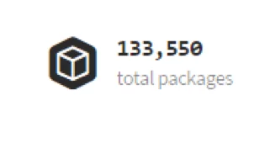](https://www.journaldev.com/wp-content/uploads/2015/03/NodeJS-Packages.png)

We can check this updates on its official website: <https://www.npmjs.com/>

Some of the Node JS Modules are written in Java Script and some are in C/C++ Language. It’s 40% modules are written in JS and 60% modules are written C/C++.

* **Express JS**

Node JS is used to develop Server-side Java Script. It also contains a separate module for Web Application Framework i.e. Express JS. HAPIJS, KOA

* **Non-blocking or Asynchronous IO**

Node JS supports Non-blocking IO i.e. it uses Asynchronous IO Model to interact with File system or to do Socket communication or network communication.

Asynchronous IO Model means if IO processing is taking more time, then it permits other processing to continue before the transmission has finished.

Java Developers are very much familiar about Blocking IO and Non-Blocking IO. Java IO package follows Blocking IO or Synchronous IO Architecture whereas Java NIO 2 follows Non-Blocking IO or Asynchronous IO Architecture.

* **Event-Driven Asynchronous Platform**  
  Node JS Platform follows Event-Driven Loop architecture to interact or handle requests. We will discuss in details about “Even-Drive Loop”.
* **MongoDB Wrappers API**  
  Node JS platform contains a separate module to integrate MongoDB No SQL database with applications. It provides a MongoDB wrapper API.

We can use this API to write JavaScript easily to interact with MongoDB database. Node JS-mongodb module uses Mongoose to interact with MongoDB database.

* **Redis Client Library API**

Node JS platform contains a separate module to integrate Redis No SQL database with applications. It provides a Redis wrapper API. We can use this API to write JavaScript easily to interact with Redis database.

* **Jade Template Engine**

Node JS platform supports many template engines to write HTML. Default template engine supported by Node JS is “Jade”.  
Jade is a whitespace-sensitive template engine for developing HTML applications very easily.

We can write template pages once and reuse them very easily to reduce development time. We will discuss how to install and write Jade templates.

* **Web Server**

We can develop and use HTTP Web Server within no time. We need to use http package to implement Web Server. We will discuss how to install http package and develop a Web Server.

* **Better Socket API**

Node JS Platform provides very good Socket Module API to develop Real-time, Multi-User Chat and Multi-Player Gaming Applications very easily. It supports Unix Socket programming like pipe().

**Advantages of Node JS**

* **One Language and One Data Format**  
  We need to use one and only one language to write whole applications i.e. JavaScript. We need to code all layers from UI to Controller to Business Layer to Persistence Layer (From Front-End to Back-End) in JavaScript only.

All layers from Front-End to Back-End support same Data Format i.e. JSON (Java Script Object Notation). UI Layer Angular JS Supports JSON Format, Server-Side Scripts written in Express JS supports JSON Format and Back-end MongoDB NO SQL supports same JSON Format.

* **Open Source**

Node JS is Open Source Module. It provides many modules for free to use in our applications.

* **Highly Scalable**

To improve our application performance, we will scale our infrastructure. There are two ways to scale any application:

* 1. Horizontal Scaling
  2. Vertical Scaling

Vertical Scalability means adding more resources to a single node. Horizontal Scalability means adding more nodes to a system.

Node JS uses Horizontal Scaling instead of Vertical Scaling to our applications. It’s consistent with today’s Cloud Technology trend.

* **Better Performance and Low Latency**

I/O operations often blocks our application because it can take a long time to read a big file, or make a large query against a database, or wait for any stream of data to fully transmit.

As Node JS follows Non-Blocking IO architecture and also uses only JavaScript to develop entire application, we can achieve better performance and low latency.

If we develop our UI and Data Intensive applications by using **MEAN Stack**, we can achieve very high performance. **MEAN Stands for MongoDB, Express JS, Angular JS and Node JS**.

* **Caching Modules**

Node JS Modules are cached once they are loaded into application for first time. Multiple calls to load a module may not cause the module code to be executed multiple times.

* **Less Problems with Concurrency**  
  Node JS does not follow Multi-Thread architecture. It follows Single-Thread with Event Loop Architecture. It serves any number of requests without any issues.  
  Node JS does NOT need to handle pooling of requests to a set of threads. That’s why it has less overhead to handle multiple requests concurrently.
* **Easy to Extend and Lightweight**  
  We can install only required modules and use them to develop applications. Whenever we need to add new feature or module, we can easily extend it.  
  By following this approach, we can also achieve very light-weight nature into our applications.
* **Faster Development and Easy to Maintain**  
  As Node JS Platform had already provided support for many modules, we can use them and develop wide variety of applications within no time. We can develop and maintain Node JS applications very easily.
* **REST API**  
  Node JS Platform supports developing RESTful Web Services API very easily.
* **Many Development Frameworks and Tools**  
  We can get many development tools like IDE and UI Frameworks to develop Node JS applications very easily.
* **Active Development Community**  
  Node JS Development Community is very active in adding new modules or packages to existing modules to support wide variety of applications development.
* **Unit Testing**  
  In Node JS applications, we need to write whole code in Java Script. Today we have many JavaScript Unit Testing frameworks and tools like Jasmin Framework.
* **Streaming Data**  
  We can easily develop Streaming-based data applications by using Node JS.
* **Creating Servers**  
  Node JS Platform has some built-in API to develop or create HTTP Server, DNS Server, TCP Server etc very easily or quickly.
* **It can handle thousands of concurrent connections with minimal overhead (CPU/Memory) on a single process**
* **Easy Module Loading process**  
  It is very easy to load required Node JS Modules into Node JS Applications. We just need to use require() statement in our application. It is similar to “import” statement in Java Programming language. We will discuss about require() in detail with some examples.

**Limitations of Node JS**

* It does NOT support Multi-threading programming.
* It does support for Computational Intensive Tasks. Node JS struggles in handling of very high computational intensive tasks, because whenever it does something long running task, it will queue all remaining incoming requests, because it follows Single-Thread Architecture with Event Loop.
* Don’t use Node JS for Blocking/Synchronous and CPU-intensive tasks.

**Who uses Node JS Platform**

Now-a-Days many people are using Node JS Platform to develop and maintain their applications. Some of the popular companies who are using Node JS Platform are;

* DOW JONES
* When-To-Manage
* Linkedin
* MicroSoft
* Twelephone (It is a service for making calls right from Twitter account)
* Yahoo
* PayPal
* eBay
* STRONGLoop
* Wallmart
* Groupon
* SAP
* PINT Web Platform (PWP)
* Cloud9 IDE
* Dropbox
* ZingChart
* Chess (It is an online game available on facebook.com)

**Node JS Applications**

We can use Node JS Platform to develop the following kind of applications.

* Network applications
* Asynchronous Events
* Intelligent Networking Proxies
* Proxy Server
* Multiplayer Game Applications
* Data Intensive Real-time applications
* Web Applications
* High Definition(HD) Voice and Video Communications
* File Uploading Tools
* Process Monitoring Tools
* Many-To-Many Instant Chatting Applications
* Many-To-Many Instant Messing Applications
* HTTP Web Server
* Real-time Logistics Systems
* Streaming Server
* High Concurrency Applications
* Communication Hubs
* Coordinators
* DNS Server
* Static File Server
* TCP Server
* Stock-Trading Dashboard

# Node JS Environment Setup – Node.js installation

In the previous section we discussed about “Introduction to Node JS Platform“. Now we have some idea about what is Node JS and what is not Node JS. We will discuss about “**How to setup Node JS Base Environment**” in Windows OS and Mac OS X.

**Node JS Base Environment Setup on Windows**

1. Access Node JS Official Website “<https://nodejs.org/en/>”

[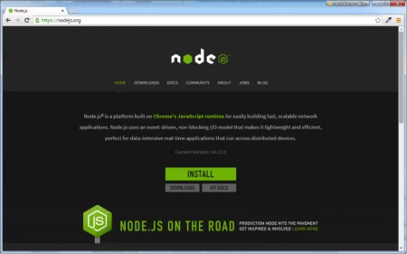](https://www.journaldev.com/wp-content/uploads/2015/03/Node.js-official-website.png)

Here we can find “INSTALL” button. If we want to download latest stable version, we can click on this button.  
If we want to select Node JS Platform based on our Hardware and Software requirements like Windows 32bit or 64bit OS, please click on “Downloads” button and select your required Node JS version to download.

[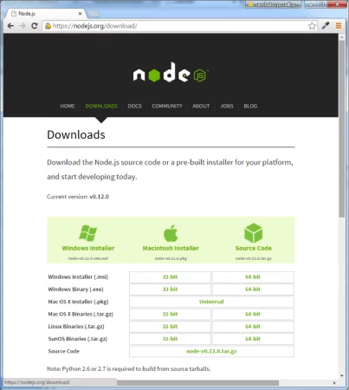](https://www.journaldev.com/wp-content/uploads/2015/03/Node.js-Download-Options.png)

1. Please click on “INSTALL” button to download latest Node JS Platform
2. Please double click on “node-xxx-x64.msi” file to start Installation process.

[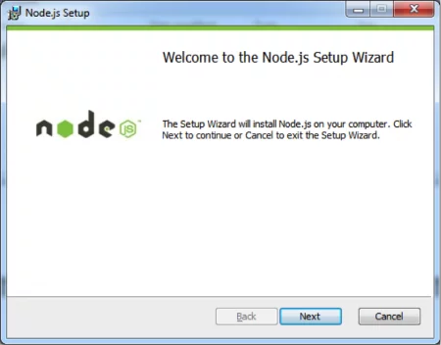](https://www.journaldev.com/wp-content/uploads/2015/03/Node.js-installation-windows-1.png)

Click on “Next” Button. Accept License Agreement and Click on “Next” Button.

[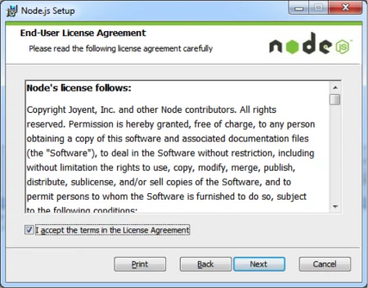](https://www.journaldev.com/wp-content/uploads/2015/03/Node.js-installation-windows-2.png)

1. Choose your required location to install.

[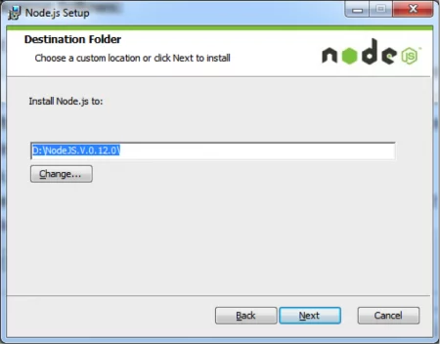](https://www.journaldev.com/wp-content/uploads/2015/03/Node.js-installation-windows-3.png)

1. Choose Default values and click on “Install” Button.

[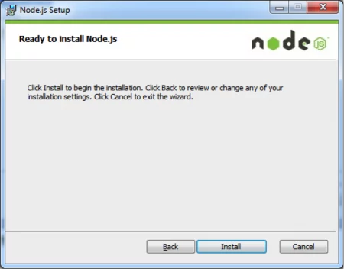](https://www.journaldev.com/wp-content/uploads/2015/03/Node.js-installation-windows-4.png)

1. Open Node JS Platform Home in your Explorer.  
   [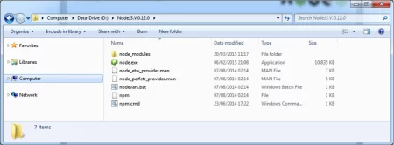](https://www.journaldev.com/wp-content/uploads/2015/03/Node.js-installation-windows-5.png)

Here we can observe node.exe and npm.cmd files and also “node\_modules” folder.

Now onwards, we will refer the following names for easier discussion purpose

NODSJS\_HOME= D:\NodeJS.V.0.12.0  
NODEJS\_MODULES= D:\NodeJS.V.0.12.0\node\_modules  
NODEJS\_NPM= D:\NodeJS.V.0.12.0\node\_modules\npm

**NOTE**:

* + If we use Windows Installer like “node-v0.12.0-x64.msi” or exe file then we don’t need to do anything to SYSTEM variables. This installer will take care of everything.
  + If we use other formats or if these are missing in your system environment variables, please add the following variables to SYSTEM properties;

PATH=C:\Users\[username]\AppData\Roaming\npm;D:\NodeJS.V.0.12.0\;%PATH%

1. Open Command prompt at NODSJS\_HOME or anywhere like D:\  
   [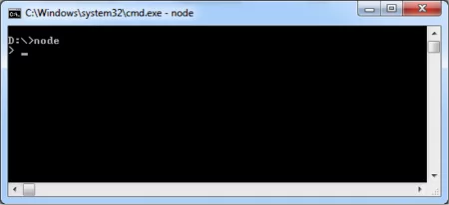](https://www.journaldev.com/wp-content/uploads/2015/03/Node.js-cmd-windows.png)

[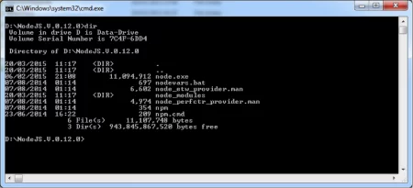](https://www.journaldev.com/wp-content/uploads/2015/03/Node.js-cmd-windows-1.png)

1. Run “node.exe” command

[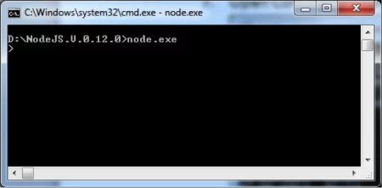](https://www.journaldev.com/wp-content/uploads/2015/03/Node.js-cmd-windows-2.png)

Now we are able to see “>” prompt, that means our Node JS Base Environment Setup is done.

1. Check Node JS Version: Use the following command to know your Node JS Version from Command prompt.

node –v

[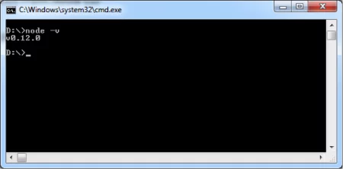](https://www.journaldev.com/wp-content/uploads/2015/03/Node.js-cmd-windows-version.png)

1. Exit from Node CLI: We can use “process.exit()” command to exit from Node CLI.

[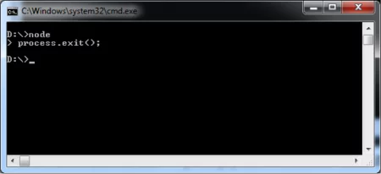](https://www.journaldev.com/wp-content/uploads/2015/03/Node.js-cmd-windows-exit.png)

We can also use **Ctrl + D** OR use **Ctrl + C Twice** to exit from Node CLI.

**Node.js Base Environment Setup on Mac OS X**

For Mac OS X, download the pkg installer and run it. You will get below screens in order.

[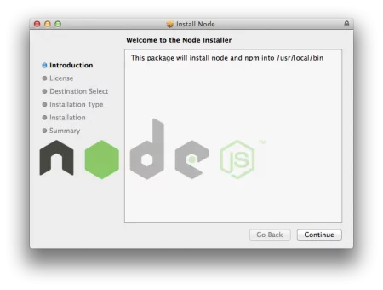](https://www.journaldev.com/wp-content/uploads/2015/03/node.js-mac-os-x-installer.png)

[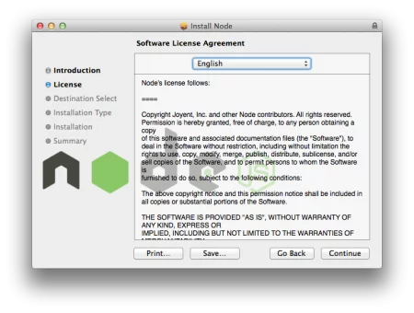](https://www.journaldev.com/wp-content/uploads/2015/03/node.js-mac-os-x-license.png)

[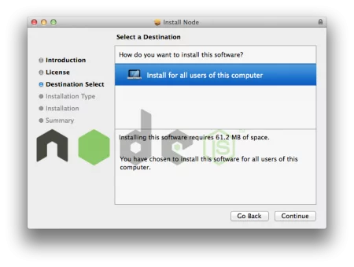](https://www.journaldev.com/wp-content/uploads/2015/03/node.js-mac-os-x-installation.png)

[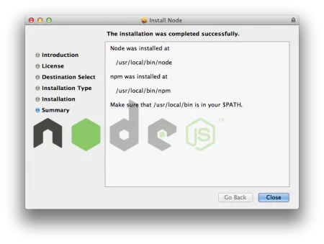](https://www.journaldev.com/wp-content/uploads/2015/03/node.js-mac-os-x-installation-success.png)

As you can see from above image, **/usr/local/bin** should be in the PATH variable. Usually it’s there by default but you can check it using below command.

$ echo $PATH

/usr/bin:/bin:/usr/sbin:/sbin:/usr/local/bin:/Library/Java/JavaVirtualMachines/jdk1.7.0\_60.jdk/Contents/Home/bin:/usr/local/apache-maven-3.0.5/bin:

$

Below are some sample commands to check the version and start Node CLI and exit it.

$ node -v

v0.12.1

$ node

> process.exit();

$ node

>

(^C again to quit)

>

$

Before starting some simple Node JS examples, we will discuss about **Major Components of Node JS Platform**.

# Node.js Components – Node.js modules, NPM install update uninstall example

We will discuss about “**Node JS Platform Major Components**” and **NPM install update uninstall** example.

### Node JS Platform Components

Node JS is Platform, not a Framework. It contains many components to develop, test and deploy Enterprise applications.

Node JS Components List:

* [Node CLI](https://www.journaldev.com/7423/node-js-components-modules-npm-install-update-uninstall-example#node-cli)
* [NPM](https://www.journaldev.com/7423/node-js-components-modules-npm-install-update-uninstall-example#npm)
* [package.json](https://www.journaldev.com/7423/node-js-components-modules-npm-install-update-uninstall-example#package.json)
* [Node Modules](https://www.journaldev.com/7423/node-js-components-modules-npm-install-update-uninstall-example#node-modules)
* [Development Tools and Frameworks](https://www.journaldev.com/7423/node-js-components-modules-npm-install-update-uninstall-example#node.js-development-tools)

[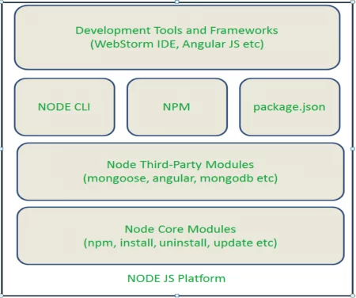](https://www.journaldev.com/wp-content/uploads/2015/03/Node.js-Components.png)

**Node CLI**

Node JS Platform has a CLI (Command Line Interface) to run basic commands and also script files.

When we install Node JS Platform, by default we will get this component. We do not need to any extra configurations for this component.

We can observe “**node.exe**” file at NODSJS\_HOME. It is also known as Node Platform CLI component.

**How to access Node CLI**:

1. Open Command prompt at NODSJS\_HOME  
   [](https://www.journaldev.com/wp-content/uploads/2015/03/Node.js-CLI-1.png)
2. Run “**node.exe**” command

[](https://www.journaldev.com/wp-content/uploads/2015/03/Node.js-CLI-2.png)

Now we are able to see NODE CLI i.e. “>”, that means our Node JS Setup is working fine.

Here we can run basic Java Script commands one by one or entire Java Script files (\*.js files) to test the basic functionality.

**NPM**

NPM stands for Node Package Manager. NPM is used to install, update, uninstall and configure Node JS Platform modules/packages very easily.

When we install Node JS Base Platform, it installs only few components, modules and libraries like Node CLI, NPM etc. From this point, we can use NPM to upgrade Node JS Platform with our required modules.

By default Node JS platform install NPM module. We can observe this at NODEJS\_HOME\node\_modules folder as shown below.

[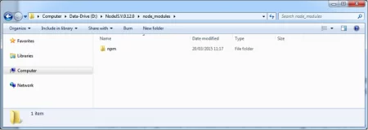](https://www.journaldev.com/wp-content/uploads/2015/03/Node.js-NPM-Home.png)

When we install any other required modules, we can observe new folders here. That means for each module or package, Node JS maintains a separate folder here.

We can observe “**npm.cmd**” in Windows environment at NODEJS\_HOME. This command is used to run NPM component from command prompt.  
[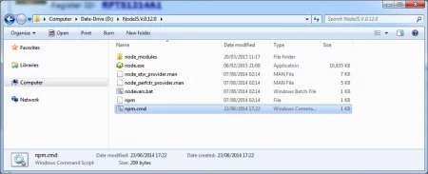](https://www.journaldev.com/wp-content/uploads/2015/03/Node.js-NPM-cmd.png)

**NOTE**: In simple words, Maven is used to build Java modules into jar files and NPM is used to create, install, install and update Node Modules.

To check npm version, run “**npm -v** command as shown in below image.

[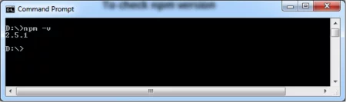](https://www.journaldev.com/wp-content/uploads/2015/03/Node.js-npm-version.png)

**NPM Command Syntax**

* **NPM Install** to install a module

[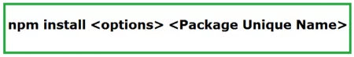](https://www.journaldev.com/wp-content/uploads/2015/03/Node.js-npm-install-module.png)

For example, npm install –g express command is used to install **Express Module**.

|  |  |  |
| --- | --- | --- |
| Sl No. | Command Parts | Description |
| 1. | -g | It tells install this module globally that is with all administrator permissions. |
| 2. | express | Express module or package unique name |

We will discuss in-detail about each module.

When we install modules by using npm, it use two modes install at two difference locations.

**Local Mode**: When we install Node JS Platform, by default it uses Local Mode to install npm module in **node\_modules** directory as shown in below screen shot.

[](https://www.journaldev.com/wp-content/uploads/2015/03/Node.js-NPM-Home.png)

Sample command for installing express module would be “**npm install express**“.

**Global Mode**: When we use **npm command with –g option**, it uses Global Mode to install modules as shown in below screen shot for “**npm install –g express**” command.

[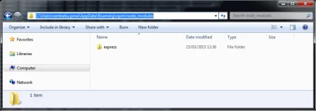](https://www.journaldev.com/wp-content/uploads/2015/03/Node.js-npm-install-module-global.png)

Here “express” module is installed with Global Mode.

* **NPM uninstall** to uninstall or remove an existing module;

[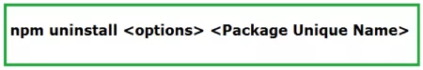](https://www.journaldev.com/wp-content/uploads/2015/03/Node.js-npm-uninstall-module.png)

* **NPM update** to update an existing module;

[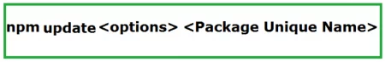](https://www.journaldev.com/wp-content/uploads/2015/03/Node.js-npm-update-module.png)

**package.json**

“**package.json**” is plain text file in JSON format. It is used to manage our application required module dependencies. We should place this file in our application root folder.

It defines information like our application name, module dependencies, module versions etc. This configurations file is very important and requires more time to explain in detail. We will discuss it in detail with some examples.

Sample package.json file;

{

"name" : "sampleapp",

"version" : "1.0.0",

"dependencies" : {

}

}

### Node Modules

Node JS is more modular platform. Each functionality is implemented by a separate module or package. It has some core modules like npm, install, uninstall, update etc and rest all modules are third-party modules.

When we install Node JS Platform, by default only one module is installed i.e. npm module. We need to use “npm” command to install required modules one by one.

All Core or Default modules are installed at /lib folder as \*.js files as show below. In our case this path refers to “D:\NodeJS.V.0.12.0\node\_modules\npm\lib”.

[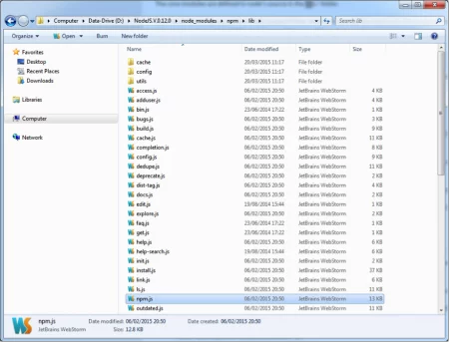](https://www.journaldev.com/wp-content/uploads/2015/03/Node.js-npm-lib.png)

Node JS has thousands of modules, but here we are going to provide some of the popular modules. We will discuss and provide some examples about these modules.

[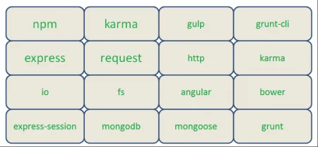](https://www.journaldev.com/wp-content/uploads/2015/03/Node.js-popular-modules.png)

A full list of Node JS Platform’s packages or modules can be found on the NPM website https://npmjs.org/.

Some of the Node JS Modules are written in Java Script and some are in C/C++ Language.

### Development Tools and Frameworks

As Node JS Platform became very popular to develop Data-Sensitive Real-time and Network applications, many companies have developed some tools and framework to ease and reduce the overhead of Node JS applications.

|  |  |
| --- | --- |
| Category | Framework/Tools |
| IDE | Eclipse with node.js plugins, Jetbrains Webstorm, Cloud9 IDE, Visual Studio Node JS Toolkit, Visual Studio Code |
| Database | Mongoose for MongoDB |
| UI Build Tools | Grunt, Yeoman, Gulp |
| CLI | Node CLI, grunt-cli |
| Authentication | Passport.js |
| UI Library Management | Bower |
| UI Frameworks | Backbone.js, Angular, Ember.js |
| Layout Frameworks | Twitter Bootstrap Framework |
| Template Engine | Jade, EJS, Hogan.JS |
| CSS Engine | Stylus, LESS, Compass |
| Unit Testing Frameworks | Jasmin, Node Unit |

# Node JS Architecture – Single Threaded Event Loop

We will look into Node JS Architecture and Single Threaded Event Loop model

## Node JS Architecture

Before starting some Node JS programming examples, it’s important to have an idea about Node JS architecture. We will discuss about “How Node JS works under-the-hood, what type of processing model it is following, How Node JS handles concurrent request with Single-Threaded model” etc. in this post.

### Node JS Single Threaded Event Loop Model

As we have already discussed, Node JS applications uses “Single Threaded Event Loop Model” architecture to handle multiple concurrent clients.

There are many web application technologies like JSP, Spring MVC, ASP.NET, HTML, Ajax, jQuery etc. But all these technologies follow “Multi-Threaded Request-Response” architecture to handle multiple concurrent clients.

We are already familiar with “Multi-Threaded Request-Response” architecture because it’s used by most of the web application frameworks. But why Node JS Platform has chosen different architecture to develop web applications. What is the major differences between multithreaded and single threaded event loop architecture.

Any web developer can learn Node JS and develop applications very easily. However without understanding Node JS Internals, we cannot design and develop Node JS Applications very well. So before starting developing Node JS Applications, first we will learn Node JS Platform internals.

### Node JS Platform

Node JS Platform uses “Single Threaded Event Loop” architecture to handle multiple concurrent clients. Then how it really handles concurrent client requests without using multiple threads. What is Event Loop model? We will discuss these concepts one by one.

Before discussing “Single Threaded Event Loop” architecture, first we will go through famous “Multi-Threaded Request-Response” architecture.

### Traditional Web Application Processing Model

Any Web Application developed without Node JS, typically follows “Multi-Threaded Request-Response” model. Simply we can call this model as Request/Response Model.

Client sends request to the server, then server do some processing based on clients request, prepare response and send it back to the client.

This model uses HTTP protocol. As HTTP is a Stateless Protocol, this Request/Response model is also Stateless Model. So we can call this as Request/Response Stateless Model.

However, this model uses Multiple Threads to handle concurrent client requests. Before discussing this model internals, first go through the diagram below.

**Request/Response Model Processing Steps**:

* Clients Send request to Web Server.
* Web Server internally maintains a Limited Thread pool to provide services to the Client Requests.
* Web Server is in infinite Loop and waiting for Client Incoming Requests
* Web Server receives those requests.
  + Web Server pickup one Client Request
  + Pickup one Thread from Thread pool
  + Assign this Thread to Client Request
  + This Thread will take care of reading Client request, processing Client request, performing any Blocking IO Operations (if required) and preparing Response
  + This Thread sends prepared response back to the Web Server
  + Web Server in-turn sends this response to the respective Client.

Server waits in Infinite loop and performs all sub-steps as mentioned above for all n clients. That means this model creates one Thread per Client request.

If more clients requests require Blocking IO Operations, then almost all threads are busy in preparing their responses. Then remaining clients Requests should wait for longer time.

[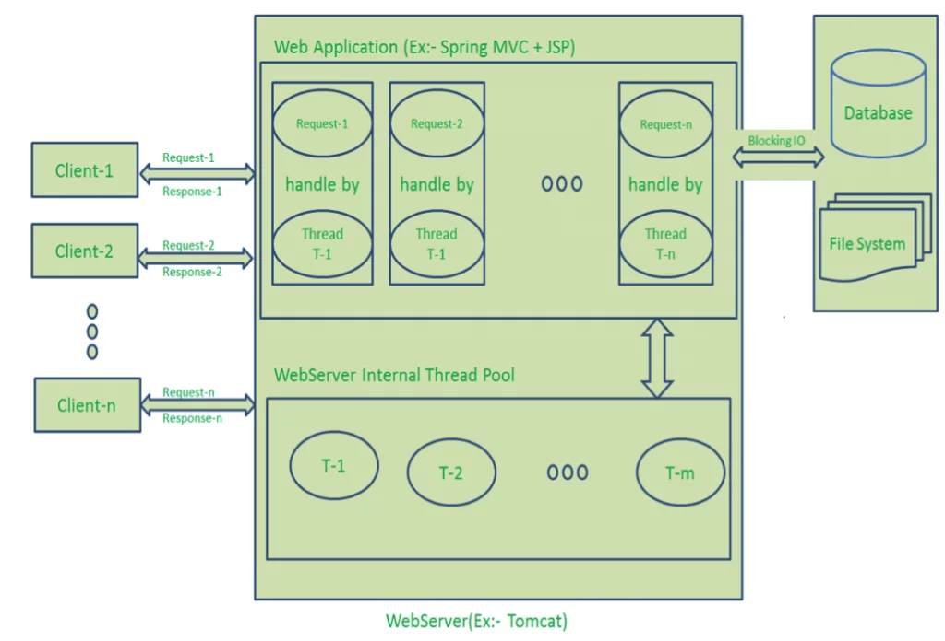](https://www.journaldev.com/wp-content/uploads/2015/04/Request-Response-Model.png)

**Diagram Description**:

* Here “n” number of Clients Send request to Web Server. Let us assume they are accessing our Web Application concurrently.
* Let us assume, our Clients are Client-1, Client-2… and Client-n.
* Web Server internally maintains a Limited Thread pool. Let us assume “m” number of Threads in Thread pool.
* Web Server receives those requests one by one.
  + Web Server pickup Client-1 Request-1, Pickup one Thread T-1 from Thread pool and assign this request to Thread T-1
    - Thread T-1 reads Client-1 Request-1 and process it
    - Client-1 Request-1 does not require any Blocking IO Operations
    - Thread T-1 does necessary steps and prepares Response-1 and send it back to the Server
    - Web Server in-turn send this Response-1 to the Client-1
  + Web Server pickup another Client-2 Request-2, Pickup one Thread T-2 from Thread pool and assign this request to Thread T-2
    - Thread T-2 reads Client-1 Request-2 and process it
    - Client-1 Request-2 does not require any Blocking IO Operations
    - Thread T-2 does necessary steps and prepares Response-2 and send it back to the Server
    - Web Server in-turn send this Response-2 to the Client-2
  + Web Server pickup another Client-n Request-n, Pickup one Thread T-n from Thread pool and assign this request to Thread T-n
    - Thread T-n reads Client-n Request-n and process it
    - Client-n Request-n require heavy Blocking IO and computation Operations
    - Thread T-n takes more time to interact with external systems, does necessary steps and prepares Response-n and send it back to the Server
    - Web Server in-turn send this Response-n to the Client-n

If “n” is greater than “m” (Most of the times, its true), then server assigns Threads to Client Requests up to available Threads. After all m Threads are utilized, then remaining Client’s Request should wait in the Queue until some of the busy Threads finish their Request-Processing Job and free to pick up next Request.

If those threads are busy with Blocking IO Tasks (For example, interacting with Database, file system, JMS Queue, external services etc.) for longer time, then remaining clients should wait longer time.

* Once Threads are free in Thread Pool and available for next tasks, Server pickup those threads and assign them to remaining Client Requests.
* Each Thread utilizes many resources like memory etc. So before going those Threads from busy state to waiting state, they should release all acquired resources.

**Drawbacks of Request/Response Stateless Model**:

* Handling more and more concurrent client’s request is bit tough.
* When Concurrent client requests increases, then it should use more and more threads, finally they eat up more memory.
* Sometimes, Client’s Request should wait for available threads to process their requests.
* Wastes time in processing Blocking IO Tasks.

### Node JS Architecture – Single Threaded Event Loop

Node JS Platform does not follow Request/Response Multi-Threaded Stateless Model. It follows Single Threaded with Event Loop Model. Node JS Processing model mainly based on Javascript Event based model with Javascript callback mechanism.

You should have some good knowledge about how Javascript events and callback mechanism works. If you don’t know, Please go through those posts or tutorials first and get some idea before moving to the next

As Node JS follows this architecture, it can handle more and more concurrent client requests very easily. Before discussing this model internals, first go through the diagram below.

The main heart of Node JS Processing model is “Event Loop”. If we understand this, then it is very easy to understand the Node JS Internals.

**Single Threaded Event Loop Model Processing Steps**:

* Clients Send request to Web Server.
* Node JS Web Server internally maintains a Limited Thread pool to provide services to the Client Requests.
* Node JS Web Server receives those requests and places them into a Queue. It is known as “Event Queue”.
* Node JS Web Server internally has a Component, known as “Event Loop”. Why it got this name is that it uses indefinite loop to receive requests and process them.
* Event Loop uses Single Thread only. It is main heart of Node JS Platform Processing Model.
* Even Loop checks any Client Request is placed in Event Queue. If no, then wait for incoming requests for indefinitely.
* If yes, then pick up one Client Request from Event Queue
  + Starts process that Client Request
  + If that Client Request Does Not requires any Blocking IO Operations, then process everything, prepare response and send it back to client.
  + If that Client Request requires some Blocking IO Operations like interacting with Database, File System, External Services then it will follow different approach
    - Checks Threads availability from Internal Thread Pool
    - Picks up one Thread and assign this Client Request to that thread.
    - That Thread is responsible for taking that request, process it, perform Blocking IO operations, prepare response and send it back to the Event Loop
    - Event Loop in turn, sends that Response to the respective Client.

[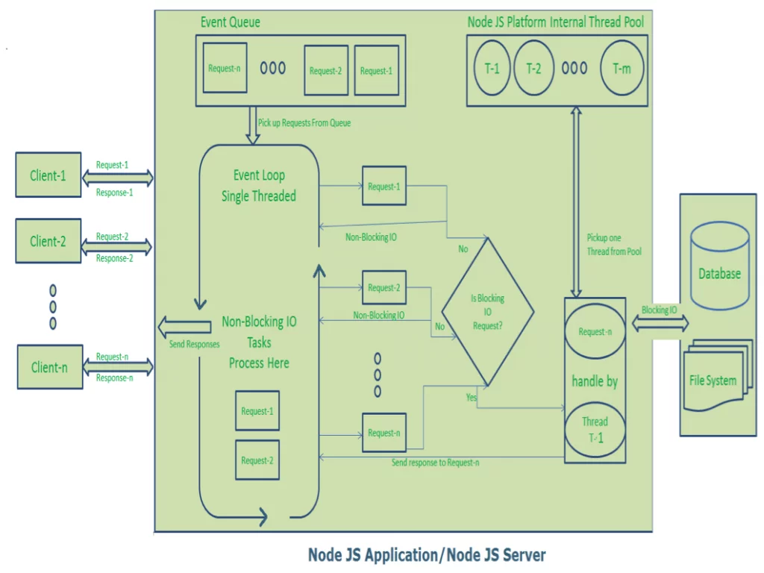](https://www.journaldev.com/wp-content/uploads/2015/04/NodeJS-Single-Thread-Event-Model.png)

**Diagram Description**:

* Here “n” number of Clients Send request to Web Server. Let us assume they are accessing our Web Application concurrently.
* Let us assume, our Clients are Client-1, Client-2… and Client-n.
* Web Server internally maintains a Limited Thread pool. Let us assume “m” number of Threads in Thread pool.
* Node JS Web Server receives Client-1, Client-2… and Client-n Requests and places them in the Event Queue.
* Node JS Even Loop Picks up those requests one by one.
  + Even Loop pickups Client-1 Request-1
    - Checks whether Client-1 Request-1 does require any Blocking IO Operations or takes more time for complex computation tasks.
    - As this request is simple computation and Non-Blocking IO task, it does not require separate Thread to process it.
    - Event Loop process all steps provided in that Client-1 Request-1 Operation (Here Operations means Java Script’s functions) and prepares Response-1
    - Event Loop sends Response-1 to Client-1
  + Even Loop pickups Client-2 Request-2
    - Checks whether Client-2 Request-2does require any Blocking IO Operations or takes more time for complex computation tasks.
    - As this request is simple computation and Non-Blocking IO task, it does not require separate Thread to process it.
    - Event Loop process all steps provided in that Client-2 Request-2 Operation and prepares Response-2
    - Event Loop sends Response-2 to Client-2
  + Even Loop pickups Client-n Request-n
    - Checks whether Client-n Request-n does require any Blocking IO Operations or takes more time for complex computation tasks.
    - As this request is very complex computation or Blocking IO task, Even Loop does not process this request.
    - Event Loop picks up Thread T-1 from Internal Thread pool and assigns this Client-n Request-n to Thread T-1
    - Thread T-1 reads and process Request-n, perform necessary Blocking IO or Computation task, and finally prepares Response-n
    - Thread T-1 sends this Response-n to Event Loop
    - Event Loop in turn, sends this Response-n to Client-n

Here Client Request is a call to one or more Java Script Functions. Java Script Functions may call other functions or may utilize its Callback functions nature.

So Each Client Request looks like as shown below:

[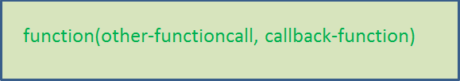](https://www.journaldev.com/wp-content/uploads/2015/04/javascript-callback-mechanism.png)

For Example:

function1(function2,callback1);

function2(function3,callback2);

function3(input-params);

**NOTE**: –

* If you don’t understand how these functions are executed, then I feel you are not familiar with Java Script Functions and Callback mechanism.
* We should have some idea about Java Script functions and Callback mechanisms. Please go through some online tutorial before starting our Node JS Application development.

### Node JS Architecture – Single Threaded Event Loop Advantages

1. Handling more and more concurrent client’s request is very easy.
2. Even though our Node JS Application receives more and more Concurrent client requests, there is no need of creating more and more threads, because of Event loop.
3. Node JS application uses less Threads so that it can utilize only less resources or memory

### Event Loop Pseudo Code

We will try to explain “How Event Loop works” in Java terminology. It is not in pure Java code.

public class EventLoop {

while(true){

if(Event Queue receives a JavaScript Function Call){

ClientRequest request = EventQueue.getClientRequest();

If(request requires BlokingIO or takes more computation time)

Assign request to Thread T1

Else

Process and Prepare response

}

}

}

That’s all for Node JS Architecture and Node JS single threaded event loop.

# Node JS Basic Examples With Node REPL (CLI) and Node IDE

In previous post, we have already spent some time on setting up Node JS Base environment. Now we will discuss about how to use Node CLI (Command Line Interface) or Node REPL(Read-Eval-Print Loop) to write and execute some basics Scripts and also discuss about Node JS IDE to write and execute simple Java Script files.

**Brief Post Content**:

Login and Exit into/from Node CLI

* Execute Simple JavaScript Commands from Node CLI
* Execute JS Files from Node CLI
* Node IDE Setup
* Develop Node JS project from Node IDE
* Execute Node JS project from Node IDE

**Login to/Exit from Node CLI**

Open command prompt anywhere in your filesystem and execute “node” to login to Node CLI as show below;

[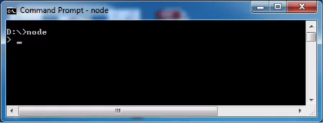](https://www.journaldev.com/wp-content/uploads/2015/04/node-cli-login.png)

Use process.exit() command to exit from Node CLI as show below.

[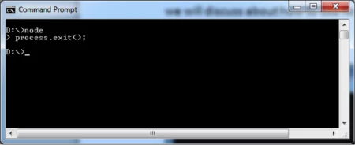](https://www.journaldev.com/wp-content/uploads/2015/04/node-cli-exit.png)

**Execute Simple JS Commands**

We can execute any JavaScript code one by one from Node CLI as show below.

[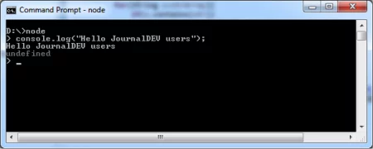](https://www.journaldev.com/wp-content/uploads/2015/04/node-cli-execute-js.png)

**Output**: Hello JournalDEV users

Like this, we can run commands/statements from Node CLI directly and we can see the output on console.

**Executing Java Script Files**

Now we will discuss about “How to run JavaScript file that is ‘\*.js’ files from Node CLI”.

If we want to run more statements at Node CLI, then we need to run them one by one. But if we write those statements into a JS file, we can run them with just single command. We need to use “node” command to run JS files from Node CLI.

**Syntax**:  
[](https://www.journaldev.com/wp-content/uploads/2015/04/nodejs-run-js-file.png)  
Here <JS-Filename> is our Java Script filename.

For example, write sample.js file.

var helloJDMessage = "Hello JournalDEV users";

console.log(helloJDMessage);

Use simple Text Editor or any Java Script editor to write this code.

[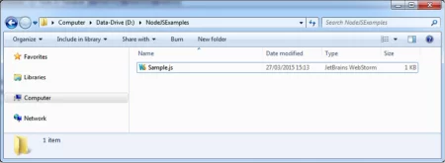](https://www.journaldev.com/wp-content/uploads/2015/04/nodejs-js-file.png)

Open command prompt at “D:\NodeJSExamples” and run “Sample.js” file as shown below.

[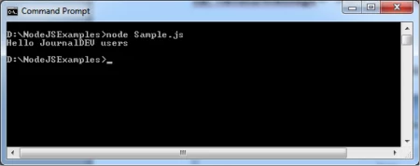](https://www.journaldev.com/wp-content/uploads/2015/04/nodejs-execute-js-file.png)

Here we can observe that we are able to print message to console when we run our Sample.js file with node command.

So far we have discussed about how to write simple JavaScript files by using some Text Editor. It’s ok to write some simple programs and for practice purpose.

However as a Developer, It’s not good practice to use Text Editors. We should use some Node IDE (Integrated Development Environment) or Tools to ease the Development process and also to reduce Development time and effort.

Now onwards, we are going to use a Node IDE known as “Eclipse Node.js IDE”. Eclipse Node.js IDE is simply known as Enide Studio. In Enide, “E” stands for Eclipse, “n” stands for Node JS and “ide” stands for IDE. We will use Enide latest version “Enide IDE 20XX”.

There is another solution with Eclipse IDE is Nodeclipse. Nodeclipse is a set of Eclipse plug-ins for programming in JavaScript, CoffeeScript with Node JS Platform.

Enide IDE 2014 is a super set of Nodeclipse plugins plus some useful plugins like Angular JS Plugin, RestClient Tool, JSON Editor Plugin, MongoDB Shell Plugin, Gradle Plugin etc. So we are going to use “Enide IDE 2014” Eclipse IDE to develop our Node JS Examples.

If you are Java Developer, I guess you are already familiar with or used Eclipse IDE in your projects.

**Enide Studio 2014 IDE Setup**

Open your Eclipse IDE and click on “Eclipse Marketplace” from “Help” menu.

[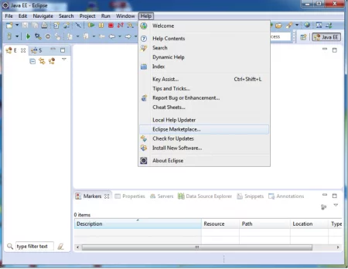](https://www.journaldev.com/wp-content/uploads/2015/04/Enide-Setup-Eclipse.png)

It opens Eclipse Marketplace as shown in below image.

[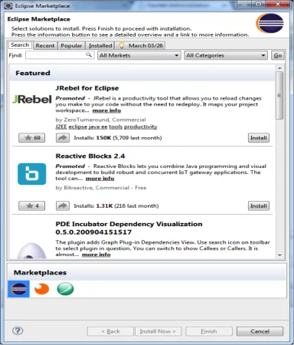](https://www.journaldev.com/wp-content/uploads/2015/04/Eclipse-Marketplace.png)

Type “enide” in “Find” text box and click on “Go” button. It searches for all available Eclipse software plugins with this name and displays as shown below:

[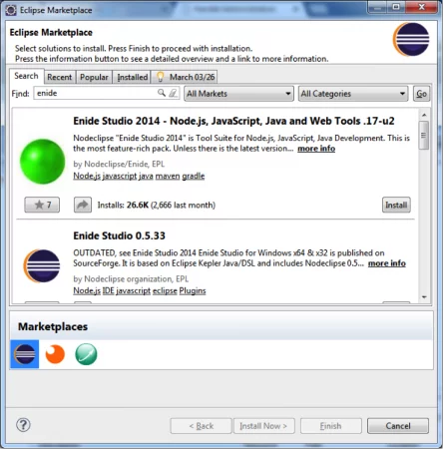](https://www.journaldev.com/wp-content/uploads/2015/04/Enide-Marketplace.png)  
It shows “Enide Studio 2014” at first place. Click on “Install” button to install it.

Accept licence and click on “Finish” Button to start installation. Once installation is over, please restart your Eclipse IDE to see these updates. Right click on “Explorer” and select “New” menu option. Now you can see some Node JS Option like “Node JS Project” etc. These are installed as part of Enide Studio installation.

[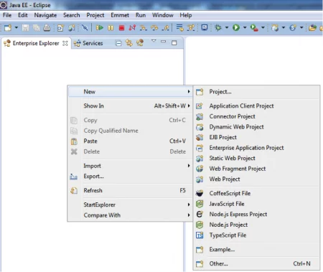](https://www.journaldev.com/wp-content/uploads/2015/04/Enide-Menu.png)

When we open “New” wizard, we can see “Nodeclipse” option as shown below.

[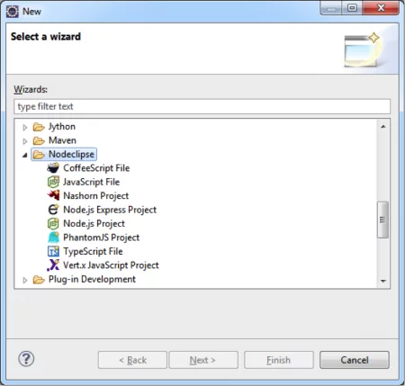](https://www.journaldev.com/wp-content/uploads/2015/04/Nodeclipse-New-Wizard.png)

If we see those options that mean Enide Studio 2014 installation is done successfully.

If we install **Enide Studio 2014** plugin after installing Node JS Base Platform, then this plugin will pick-up all Node JS Platform settings as shown below.

Select “Preferences” option from “Window” menu.

[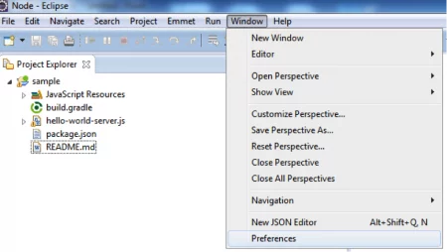](https://www.journaldev.com/wp-content/uploads/2015/04/Eclipse-Preferences.png)

[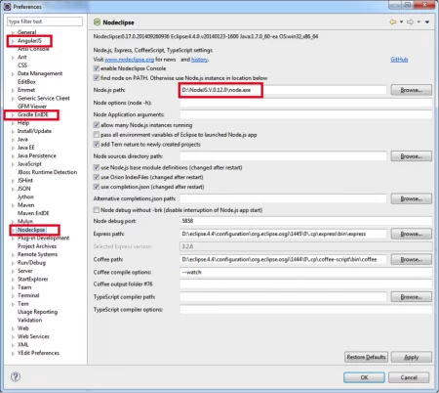](https://www.journaldev.com/wp-content/uploads/2015/04/Nodeclipse-preferences.png)

If you install Node JS Platform after this step, please check and set any missing properties in this Preferences wizard.

[Learn more](https://aax-eu.amazon-adsystem.com/x/c/QpuLQNXuWAs414WJelmWHX4AAAGAJkK4sAMAAAalBLnh_tA/https:/www.interwetten.com/go/?dl=1070&bn=Video-SB-Banner-SEM-TR-App-9239-DSP-AT&utm_source=amazon&utm_medium=programmatic&utm_campaign=app_download&utm_content=at" \t "_blank)

volume is gedempt

**Develop Node JS Project with Enide Studio Node IDE**

Create new Node JS Project by selecting “New >> Other…” from “File” menu.

[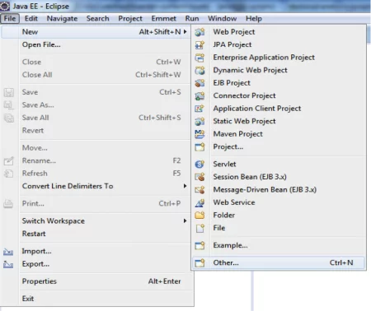](https://www.journaldev.com/wp-content/uploads/2015/04/Nodejs-project.png)

Select Node.js Project from “New” wizard. Click on “Next” button.

[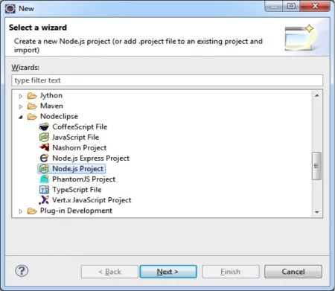](https://www.journaldev.com/wp-content/uploads/2015/04/Node.js-project-Enide.png)

Provide new project name as “sample” and also select “Template to use” as “Hello World”.

[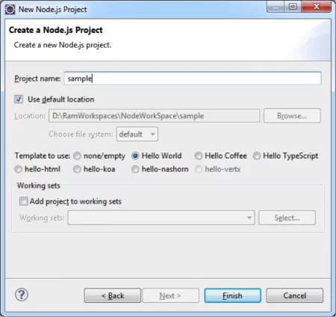](https://www.journaldev.com/wp-content/uploads/2015/04/Node.js-project-template.png)

Click on “Finish” button. It creates new Node JS Project “sample” and also download libraries.

[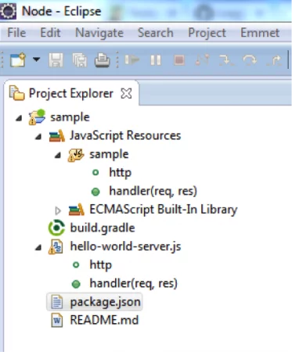](https://www.journaldev.com/wp-content/uploads/2015/04/Node.js-project-structure.png)

It automatically changes to “Node” Eclipse Perspective as shown below.

[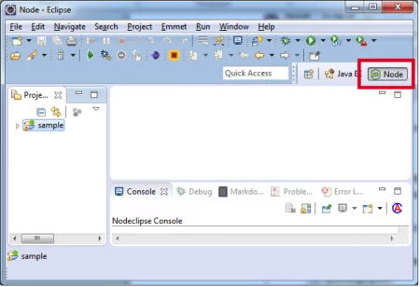](https://www.journaldev.com/wp-content/uploads/2015/04/Eclipse-Node-Perspective.png)

Create a JavaScript file sample.js as shown below by right click on “sample” Node JS Project and select “New” >> “JavaScript file”.  
[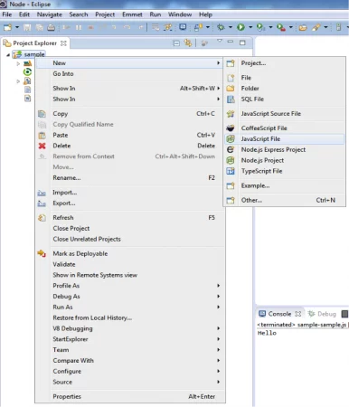](https://www.journaldev.com/wp-content/uploads/2015/04/Node.js-New-JS-File.png)

Provide JavaScript file name and click on Finish button.

[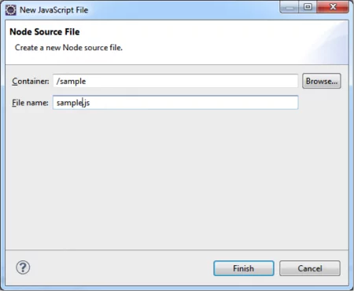](https://www.journaldev.com/wp-content/uploads/2015/04/Node.js-file-name.png)

Provide some JavaScript code as shown below.

[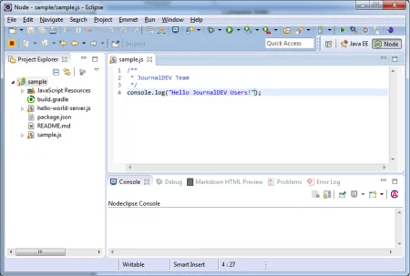](https://www.journaldev.com/wp-content/uploads/2015/04/Node.js-js-file-content.png)

**Execute Node JS Project from Node IDE**

Execute sample.js file from Enide Studio IDE. Select and Right Click on sample.js file. Select “Run As” >> “Node Application” option.

[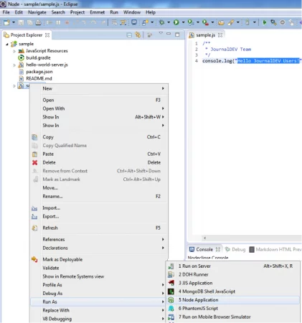](https://www.journaldev.com/wp-content/uploads/2015/04/Node.js-run-as-application.png)

Observe the output at IDE Console.

[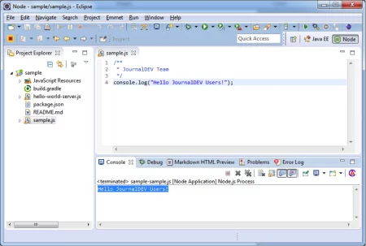](https://www.journaldev.com/wp-content/uploads/2015/04/Node.js-execute-js-output.png)

**Output**: Hello JournalDEV Users!

Now we have some idea about how to use Enide Studio IDE to develop and run Node JS Applications with simple Java Script file.

We will discuss how to develop Node JS full-fledged application with Angular JS, Express JS, Mongo DB, RESTful WebServices etc in coming posts.

# Importance of package.json in Node JS Applications

Before starting Node JS applications development, we should learn some basics and importance of package.json file. Every Node JS application or module or package should contain this package.json file.

**Prerequisite**: You should have some basic knowledge about JSON file format, JSON data types etc.

### What is package.json?

package.json is a plain JSON(Java Script Object Notation) text file which contains all metadata information about Node JS Project or application.

Every Node JS Package or Module should have this file at root directory to describe its metadata in plain JSON Object format.

We should use same file name with same case “package” and same file extension “\*.json”.

Why that filename is “package”: because Node JS platform manages every feature as separate component. That component is also known as “Package” or “Module”.

### Who uses package.json file?

NPM (Node Package Manager) uses this package.json file information about Node JS Application information or Node JS Package details.

package.json file contains a number of different directives or elements. It uses these directives to tell NPM “How to handle the module or package”.

### Mandatory Directives of package.json file

package.json file contains a number of different directives or elements. Some are mandatory and some are optional directives.

#### Mandatory Directives

ackage.json file contains two mandatory directives;

1. name
2. version

**name**: It is a unique Node JS Package (Module) name or our Node JS Project name. This name should be in lower case letters. It is mandatory directive. Without this directive, we cannot install our Node JS Package by using NPM.

JSON file follows key-value pair format. Key is of JSON String type and value may be of any JSON Data type. Key and Value elements are separated by colon “:”.

Here “name” directive’s value is of JSON String type.

**Example:**

"name":"simplename"

When we run “npm install <package-name>” command, NPM reads package.json file available at root directory and checks that package name by reading this name directive. If it does not find this directive in package.json file then it throws an error message and cannot install that package.

**version**: version is the Node JS Package version number. It is a Mandatory directive in package.json file. NPM uses this version number to install or uninstall or update the right package in our NODE JS Environment.

“version” directive’s value is of JSON String type.

If NPM does not find this directive in package.json file then it throws an error message and cannot install that package.

**Example**:

"version":"1.0.0"  
Here we need to define 3 parts of version: major, minor and patch

Both name and version directives of package.json file identifies a Node JS Package uniquely.

|  |  |  |
| --- | --- | --- |
| Sl No. | Directive | Description |
| 1. | name | Unique Package name |
| 2. | version | Package version number |

**Example of sample package.json file**

{

"name" : "sample",

"version" : "1.0.0"

}

#### Optional Directives

package.json file may contain many optional directives. We should use them only if our Node JS package really requires. We will discuss some important optional directives here.

**description**: It is the description of the Node JS Project or module. We need to provide brief and concise description about “What this module does”.

**dependencies**: Every Node JS Project or Module may dependent on other Node JS or Third Party Modules or our own Custom Modules. We should provide all those dependencies by using this “dependencies” directive.

“dependencies”: {  
<Define all your Module Dependencies here in key-value pairs>  
}

Here key is module name and value is required module version. For example;

"dependencies": {

"mypackage": "1.0.0",

"async": "0.8.0",

"express": "4.2.x"

}

Complete package.json file example:

{

"name" : "sampleapp",

"version" : "1.0.0"'

"dependencies": {

"mypackage": "1.0.0",

"async": "0.8.0",

"express": "4.2.x"

}

}

Here sample app is depending on 3 other Node JS Modules: mypackage (My own Custom Module), async and express (Node JS Modules)

While defining dependencies version we can use some pattern matching syntax.

**Scenario 1**: Any available version with \* character

"dependencies": {

"mypackage": "\*"

}

It will pickup any available version of mypackage module.

**Scenario 2**: Range selection with ~ symbol

"dependencies": {

"mypackage": "~0.2.0"

}

It pickup any available version of mypackage module between >=0.2.0 and < 0.3.0(Exclusive).

In development mode, we always want our Node JS application to use latest available module from Node JS repository.

**Scenario 3**: Range selection with ^ symbol

"dependencies": {

"mypackage": "^0.2.0"

}

It will pickup any available version of mypackage module between >=0.2.0 and < 1.0.0(Exclusive).

**repository**: This directive is used to specify the URL where your source code is live for other people to contribute to your module or to learn your module. Its syntax is shown below.

"repository": {

<Define your URL here>

}

Here we need to define two elements:

* Type of source to which you are going to provide URL
* url

We define these two elements in key-value pairs. Here key is element name and value is either type of source or url.

For example;

"repository": {

"type" : "git",

"url" : "https://github.com/journaldev/jd.git"

}

**Complete package.json file example with mandatory and optional directives**:

{

"name" : "sample",

"version" : "1.0.0"'

"repository": {

"type" : "git",

"url" : "https://github.com/journaldev/jd.git"

},

"dependencies": {

"mypackage": "1.0.0",

"async": "0.8.0",

"express": "4.2.x"

}

}

### How to create package.json in Enide Studio IDE?

We have already discussed in last post about [how to setup Enide Studio 2014 IDE](https://www.journaldev.com/7527/node-js-basic-examples-with-node-cli-and-node-ide) with Eclipse and also how to create a new Node.js project.

When we create new Node.js Project in Enide Studio, it will create a package.json file automatically with default values as shown below.

[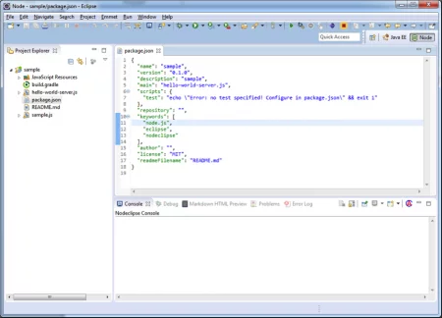](https://www.journaldev.com/wp-content/uploads/2015/04/Enide-package.json_.png)

We will use this package.json file knowledge in coming posts to develop our Node JS full-fledged Applications.

# NodeJS Export and Import Modules

We have discussed about “How to install Enide Studio 2014 IDE” and also “**How to create a Node JS Application**“.

Before discussing about “How to create new Node JS Modules and How to reuse them in other Node JS Modules”, first of all we need to have some good knowledge about how to **export** and **import** a Node JS module.

In this session, we are going to discuss the following two important Node JS concepts theoretically.

* How to export a Node JS Module
* How to import a Node JS Module

We will use this knowledge especially in next session, but also in all coming examples.

**Export a Node JS Module**

First and foremost thing we need to understand is why we need to export a Node JS Module?

Node JS has provided almost all required modules (We can check this updates on its official website: <https://www.npmjs.com/>. It is also known as Node JS Module Repository). But in some realtime applications, we may have some application functionality, which is used many places in that application but not available at Node JS Module Repository.

In this scenario, to get Reusability benefit, we need to create our own new Node JS module. Just creating new Module is not enough to use it in other modules of the system. We need to export this module so that other modules will reuse it.

If you are a UI or Java Developer, then is familiar to you. If we have any common or reusable component in Java-based application, then we develop it as a separated project, create a Jar file and add it at required projects classpath.

Don’t worry too much about how to create a Node JS Module at this point. We will discuss how to create our own new Node JS Module in future.

Node JS Platform has provided a technique to export the following things so that other modules can reuse them without redefining.

* Variable
* Function
* Module

To export all these three, we have to use same technique. Node JS has provided an Object **“exports”** to do this.

**Syntax:**

[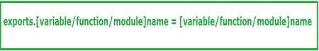](https://www.journaldev.com/wp-content/uploads/2015/04/NodeJS-export-module-1.png)

We will see one by one now with some examples. Here we are discussing them theoretically only. We will take one realtime scenario and implement one Node JS Application

**How to export a JavaScript Variable**

We use Node JS **“exports”** object to export a Node JS Module’s Variable so that other Modules can reuse it. In realtime, we don’t just export a Variable. However just for practice purpose and also to make it clear to beginners, we are discussing this separately.

**Syntax:**

[](https://www.journaldev.com/wp-content/uploads/2015/04/NodeJS-export-module-2.png)

**Example:**

Let us assume that we have created a simple Node JS Project with one JavaScript file: pi.js file with the following content.

var PI = 3.1416

exports.PI = PI;

Here we have exported PI variable as exports.PI with name PI. That’s means other Node JS project can use this variable very easily just using PI name.

**How to export a JavaScript Function:**

We use Node JS same **“exports”** object even to export a Node JS Module’s JavaScript function so that other Modules can reuse it. In realtime, we may do this but it is not recommended to use always.

**Syntax:**

[](https://www.journaldev.com/wp-content/uploads/2015/04/NodeJS-export-module-3.png)

**Example:**

Let us assume that we have created a simple Node JS Project with one JavaScript file: arthmetic.js file with the following content.

function add(a,b){

return a + b;

}

function sub(a,b){

return a - b;

}

function mul(a,b){

return a \* b;

}

function div(a,b){

return a / b;

}

exports.add = add

exports.sub = sub

exports.mul = mul

exports.div = div

Here we have exported all 4 JavaScript functions separately. That’s means other Node JS project can reuse them directly.

It is a simple Arithmetic application. However if we take some realtime Node JS Applications, we can observe plenty of JavaScript files and each file may contain plenty of functions. In this scenario, it is very tedious process to export each and every function separately.

To resolve this issue, we need to use Exporting a Node JS module technique as described below.

**How to export a Node JS Module:**

We use Node JS same **“exports”** object even to export a Node JS Module so that other Modules can reuse it. In realtime, it is recommended.

**Syntax:**

[](https://www.journaldev.com/wp-content/uploads/2015/04/NodeJS-export-module-4.png)

**Example:**

Let us assume that we have created a simple Node JS Project with one JavaScript file: arthmetic.js file with the following content.

exports.arthmetic = {

var PI = 3.1416;

function add(a,b){

return a + b;

}

function sub(a,b){

return a - b;

}

function mul(a,b){

return a \* b;

}

function div(a,b){

return a / b;

}

}

Here we have exported all 4 JavaScript functions and PI variable with just one exports statement. That’s means other Node JS project can reuse all functions and PI very easily.

**Import a Node JS Module**

If we observe a Node JS Application or Module, it may dependent on other existing Node JS modules or our own Modules.

The major advantage of Modularity is reusability. We don’t need to redevelop the same existing functionality. We can import a Module and reuse that module functionality very easily.

**How to import a Node JS Module:**

We use same technique to import our modules or existing Node JS Modules.

Node JS Platform has provided a function call **“require()”** to import one module into another.

**Syntax:**

[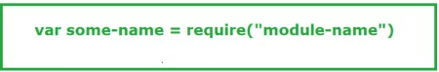](https://www.journaldev.com/wp-content/uploads/2015/04/NodeJS-import-module-1.png)

Here module-name is our required Node JS module name.

some-name is reference name to that module.

This require() call import the specified module and cached into the application so that we don’t need to import it again and again.

**Example:**

* To import our own Node JS module
* var arthmetic = require("arthmetic");
* To import existing Node JS Module

Import Node JS “express” module;

var arthmetic = require("express");

Import Node JS “mongoose” module;

var mongoose = require("mongoose");

This require() call is similar to **“import”** statement in Java. We use import statement to import a package, class, interface etc into another class or interface.

Now we got some knowledge about how to export and import a Node JS module. We will use this knowledge to create our own Node JS Modules in next post.

# How to Create Node JS Reusable Modules

In our previous session, we have discussed about “How to export and import a Node JS Module” with syntax and some examples. If you got any doubts through previous section , please go through them first and come back to this point because now onwards we are going to use that knowledge to develop all our examples.

We have already discussed that Node JS is Modular Platform. Node JS Platform contains many modules or packages developed by Node JS or Third-Party clients. I guess you have some curiosity to know about the implementation of those existing Node JS Modules.

Node JS Platform has provided an approach to create our own modules (if required) to match our project requirements. It is very easy and simple to create our own Node JS Modules.

We are going to discuss the approach to create our own Node JS Modules and also how to reuse that module as a Node JS Library in other module in this post.

**Real-time Scenario**:  
As Developer or even in academic, I guess we all have developed a simple program to print “Fibonacci sequence”.

Fibonacci sequence is a sequence of numbers in which first two numbers are 1, 1 and each subsequent number is the sum of the previous two numbers. For example 1,1,2,3,5,8,13 and so on.

To develop custom or our own Node JS Modules or Packages, we need to do the following two steps:

1. Create new Node JS Module
2. Publish our own Node JS Module

We will discuss these two steps in detail by using the scenario explained above.

**How to create new Node JS Module**

We are going to develop a new Node JS Module with “fabonacci” name. We are going to use **Enide Studio IDE 2014** to develop this example.

Please use the following steps to create new Node JS Module:

* Create a Node JS Project (Please refer “Node JS Basic Examples With Node REPL (CLI) and Node IDE” post for complete steps)

Enter Project name: fabonacci

Select Template to use: none/empty

[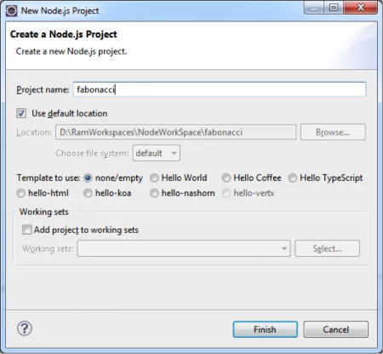](https://www.journaldev.com/wp-content/uploads/2015/04/New-Node.js-Project.png)

* It creates a new Node JS Project with one README.md file as shown below;

[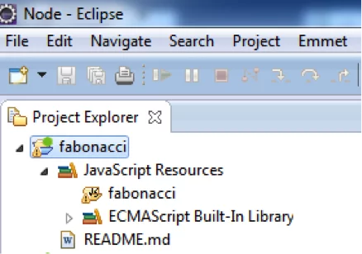](https://www.journaldev.com/wp-content/uploads/2015/04/New-Node.js-Eclipse-Project.png)

* Create a Java Script file named “fabonacci.js”  
  [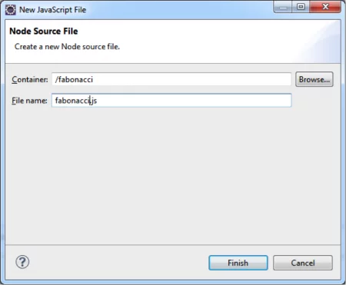](https://www.journaldev.com/wp-content/uploads/2015/04/New-Node.js-File.png)
* Provide implementation to generate numbers in Fibonacci Sequence as below.

fabonacci.js

/\*\*

\* JournalDEV

\* Fabonacci Sequence : 1,1,2,3,5,8,13,...

\*/

function fabonacci(num1,num2){

return num1+num2;

}

* Export this module functionality to use in other Node JS Modules. Node JS Platform has provided “exports” object to do this as shown below;
* exports.fabonacci = fabonacci;
* Create a package.json file at root directory as shown below. If you have already gone through my previous posts to create “simple” application, simply copy package.json from that project and modify accordingly. Otherwise, please go through the following two steps.

Step 1: “New” >> “Other” to open “New Wizard” window  
Step 2: “JSON” >> “JSON File”

[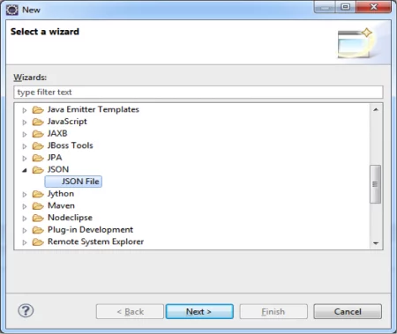](https://www.journaldev.com/wp-content/uploads/2015/04/New-Node.js-JSON-File.png)

Click on “Next” button and provide File name as package.json

[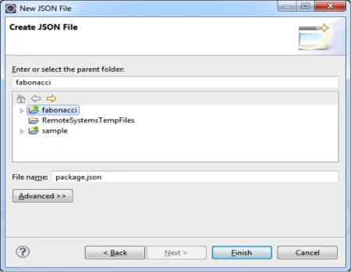](https://www.journaldev.com/wp-content/uploads/2015/04/New-Node.js-package.json-File.png)

Click on Finish button. It creates empty JSON file. Copy below JSON content to package.json file and save it.

package.json

{

"name": "fabonacci",

"version": "1.0.0",

"description": "fabonacci sequence",

"main": "fabonacci",

"author": "JournalDEV",

"engines":{

"node":"\*"

}

}

* Now our Node JS project looks like below;

[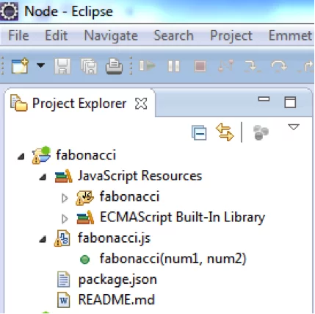](https://www.journaldev.com/wp-content/uploads/2015/04/Node.js-fibonacci-project.png)

**How to use our Node JS Module**

First we will create a new Node JS Project like “fabonacci-client” then we will use “fabonacci” module to test it.

* Create new Node JS Project like “fabonacci-client”.  
  [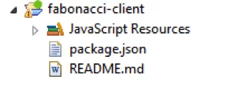](https://www.journaldev.com/wp-content/uploads/2015/04/Node.js-fibonacci-client-project.png)
* Copy package.json file from “fabonacci” to “fabonacci-client” and modify accordingly.

package.json

{

"name": "fabonacci-client",

"version": "1.0.0",

"description": "fabonacci sequence client",

"main": "fabonacci-test",

"author": "JournalDEV",

"engines":{

"node":"\*"

}

}

* Open command prompt and goto “fabonacci-client” folder and run command as shown in the image.  
  [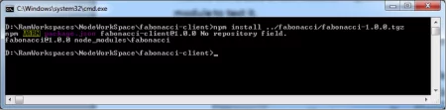](https://www.journaldev.com/wp-content/uploads/2015/04/NPM-install-command.png)

This step is known as publishing our own newly created Node JS Module into other Node JS Module.

* Now “fabonacci-client” includes “fabonacci” module as shown below.  
  [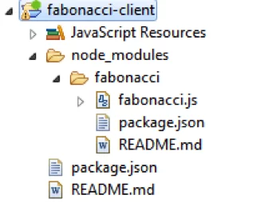](https://www.journaldev.com/wp-content/uploads/2015/04/NPM-module-eclipse-project.png)
* Create a JavaScript file to test “fabonacci” module functions.

fabonacci-client.js

/\*\*

\* Fabonacci Sequence : 1,1,2,3,5,8,13,...

\*/

/\*\*

\* New node file

\*/

var fab = require("fabonacci");

var num = fab.fabonacci(1,1);

console.log(num);

* Finally project looks like below image;

[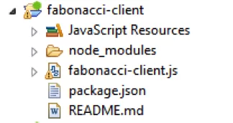](https://www.journaldev.com/wp-content/uploads/2015/04/Node.js-fibonacci-client-eclipse-project.png)

* Run fabonacci-client.js in Enide Studio IDE 2014 as “Node Application”.

[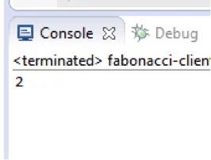](https://www.journaldev.com/wp-content/uploads/2015/04/Node.js-execute.png)

Change fabonacci-client.js as shown below and run it again to see next number in the Fibonacci Sequence.

var num = fab.fabonacci(1,2);

[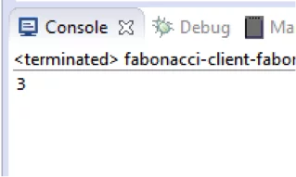](https://www.journaldev.com/wp-content/uploads/2015/04/Node.js-execute-1.png)

As a Java Developer, I guess you have already done this kind of activities in your projects. When we have a common or reusable component in our project requirements, then we will develop this component as a separate project, package this component into a JAR and place this JAR file in other Project module’s CLASSPATH, so that those dependent Project modules will reuse that component.

We did similar kind of approach in this post too. We have created a new Node JS Module – fabonacci, packaged that module, add this module into our new Node JS Project and reuse those functions defined in fabonacci in our new Node JS Project.

# Node FS – NodeJS Create File, Read File, Write to File

Node FS stands for NodeJS File System module. In my previous post, we have already discussed about how to import a Node JS module using require() call. Before reading this post, please go through this post “Node JS Export and Import Modules” to know require() call usage.

## Node FS

In this session, we are going to discuss about Node JS Platform “fs” module. FS Stands for **File System**. This module is also known as **IO or FileSystem or Stream module**.

6.4M

216

Java Tricky Program 16 - Autoboxing, Inheritance and Overriding

## NodeJS FS Module Post Brief

1. Introduction to Node FS Module
2. Node JS Create File
3. Node JS Write to File
4. Node JS Read File

### Introduction to Node FS Module

Node FS Module provides an API to interact with File System and to perform some IO Operations like create file, read File, delete file, update file etc.

Like some Node modules for example “npm”, “http” etc, Node JS “fs” also comes with basic Node JS Platform. We don’t need to do anything to setup Node JS FS module.

### Node FS Module import

We just need to import node fs module into our code and start writing IO Operations code.

To import a node fs module;

var fs = require("fs");

This require() call imports Node JS “fs” module into cache and creates an object of type Node FS module. Once it’s done, we can perform any IO Operation using node fs object.

Let us assume that our ${Eclipse\_Workspace} refers to D:\RamWorkspaces\NodeWorkSpace.

Now onwards, I’m going to use this variable to refer my Eclipse workspace.

As a Java or DOT NET or C/C++ developers, we have already learned and wrote some IO Programs.

IO or Streams are two types:

* Write Stream – To write data to a Stream.
* Read Stream – To read data from a Stream.

### Node JS Create File

Now we will discuss about how to create a new file using Node JS FS API.

1. Create a Node JS Project in Eclipse IDE.  
   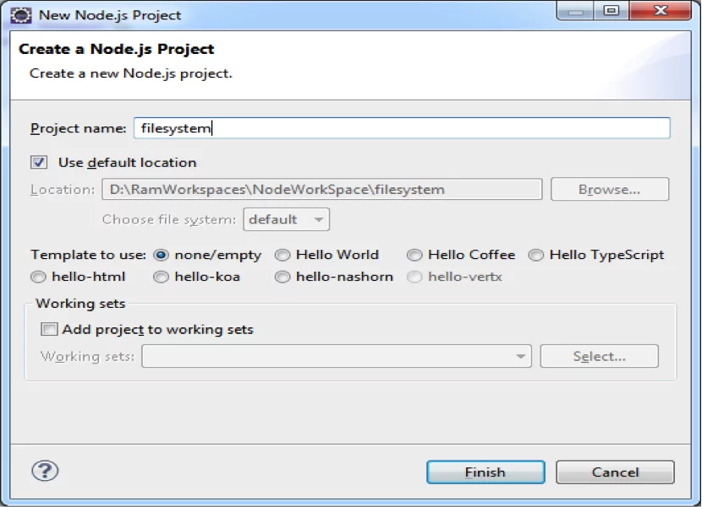
2. Copy package.json file from previous examples and update the required things.
3. {
4. "name": "filesystem",
5. "version": "1.0.0",
6. "description": "File System Example",
7. "main": "filesystem",
8. "author": "JournalDEV",
9. "engines":{
10. "node":"\*"
11. }
12. }
13. Create a JavaScript file with the following content;

fs-create-file.js

/\*\*

\* Node FS Example

\* Node JS Create File

\*/

var fs = require("fs");

var createStream = fs.createWriteStream("JournalDEV.txt");

createStream.end();

**Code Description**:

var fs = require("fs") require() call loads specified Node FS module into cache and assign that to an object named as fs.

fs.createWriteStream(filename) call is used to create a Write Stream and file with given filename.

createStream.end() call ends or closes the opened stream.

1. Before executing fs-create-file.js, first observe the filesystem project content and you will notice that “JournalDEV.txt” file is not available.
2. Open command prompt at ${Eclipse\_Workspace}/filesystem and run node commend to execute fs-create-file.js file as shown in below image.

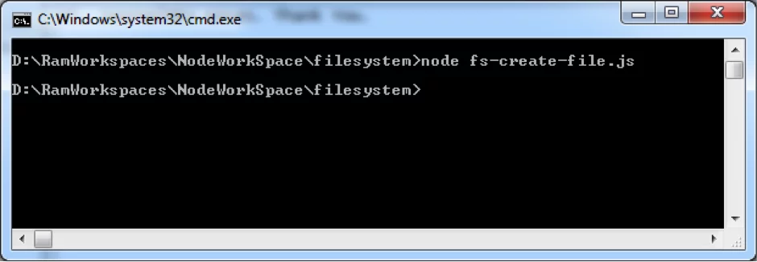

Notice your project directory contents now, you will notice an empty file named “JournalDEV.txt”.

### Node JS Write to File

We will use Node FS API to create a new file and write some data into that. It is continuation to our previous example.

1. Remove previously created “JournalDEV.txt” from ${Eclipse\_Workspace}/filesystem folder
2. Create a Java Script file with the following content:

fs-write-file.js

/\*\*

\* Node FS Example

\* Node JS Write to File

\*/

var fs = require("fs");

var writeStream = fs.createWriteStream("JournalDEV.txt");

writeStream.write("Hi, JournalDEV Users. ");

writeStream.write("Thank You.");

writeStream.end();

createStream.write(sometext) call is used to write some text to a file.

1. Open command prompt at ${Eclipse\_Workspace}/filesystem and run node commend to execute fs-write-file.js file as shown below.  
   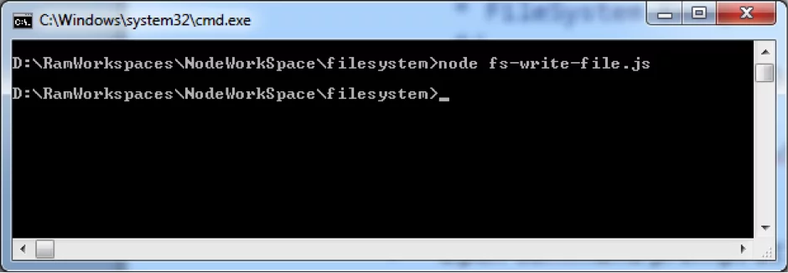
2. Go to ${Eclipse\_Workspace}/filesystem folder and open “JournalDEV.txt” to verify its content.  
   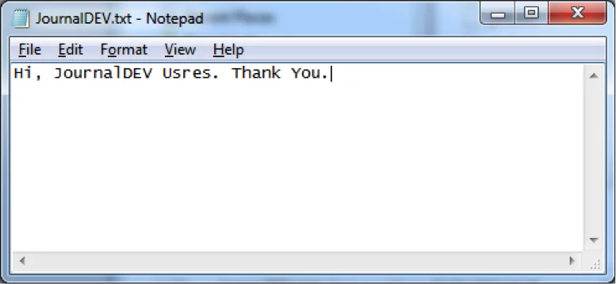

Now we have created a new file and write some data into that file.

### Node JS Read File

We will use Node FS API to open and read an existing file content and write that content to the console. It is continuation to our previous examples.

Here we are going to use named JavaScript function. Go through this example to understand this.

1. Create a Java Script file with the following content.

fs-read-file1.js

/\*\*

\* Node FS Read File

\* Node JS Read File

\*/

var fs = require("fs");

function readData(err, data) {

console.log(data);

}

fs.readFile('JournalDEV.txt', 'utf8', readData);

**Code Description**:

readData() is a JavaScript function which takes two parameters;

* 1. **err**: it’s an error object. When our program fails to open or read data from a file, then FS module writes some error message into this parameter.
  2. **data**: it’s a variable to hold some data.

This function takes data parameter and prints that data to a console.

fs.readFile() is Node JS FS API. It takes three parameters;

* 1. file name
  2. file data format to read
  3. A JavaScript function or JavaScript anonymous function

readFile() reads data from a filename (first parameter) in given format (second parameter) and uses function given at third parameter to do some operation.

Here we are using a plain JavaScript function as the third Parameter. We will see how to use JavaScript anonymous function in next example.

In our example, readFile() reads data from “JournalDEV.txt” file and writes to console.

If we don’t use ‘utf8’ format, then we will get binary data. We will verify this in few moments.

1. Open command prompt at ${Eclipse\_Workspace}/filesystem and run node commend to execute fs-read-file1.js file.

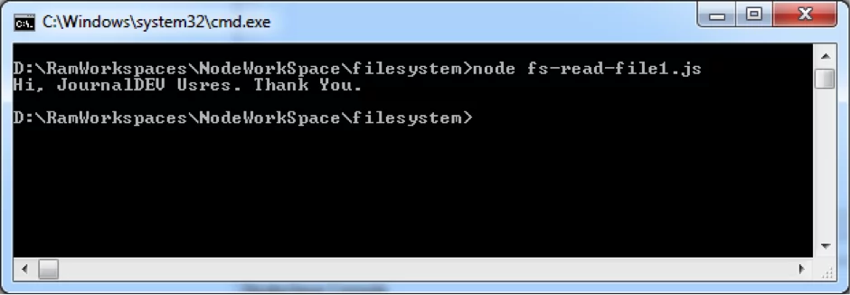

Now we have observed that our code has successfully open a file, reads its content and writes its content to the console.

### Node.js read file as binary

Now we are going to use JavaScript anonymous function to read data from a file. Go through this example to understand this. It’s similar to previous fs-read-file1.js example only but with anonymous function. If you are not familiar with JavaScript anonymous functions, please go through some JavaScript tutorial and get some idea.

Create a Java Script file with the following content;

fs-read-file2.js

/\*\*

\* Node FS File System Module

\* Node.js read file example

\*/

var fs = require("fs");

fs.readFile('JournalDEV.txt', 'utf8', function(err, data) {

console.log(data);

});

**Code Description**:

Here readFile() is using JavaScript anonymous function to read data from a file and write that file content to the console.

When we run this file, we will get same output as fs-read-file2.js example.

Now remove “utf8” data format to see binary output.

/\*\*

\* Node FileSystem Module

\* Node JS Read File Binary Data

\*/

var fs = require("fs");

fs.readFile('JournalDEV.txt', function(err, data) {

console.log(data);

});

Execute above file and observe the output as shown in below image.  
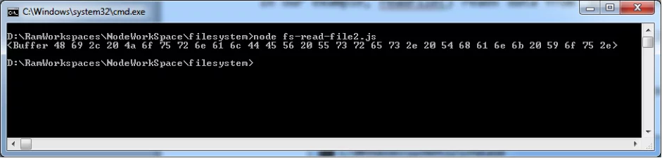

**Bonus TIP**: To learn Node JS FS API in depth, please use **Enide 2014 Studio** and know all available functions and usage as shown below.

[anyFSAPIObject] + Press . (dot) + After dot Press (CTRL + Space Bar)

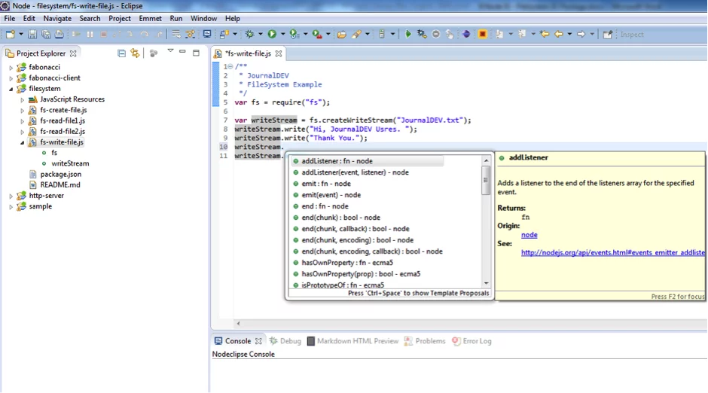

Now we are familiar with Node FS module. We are going to use this knowledge in next posts, especially in HTTP Module post.

# Node.js HTTP Package – Creating HTTP Server

An HTTP server caters to client requests and sends appropriate response. For example, JournalDev is also running on HTTP server. If you have landed here directly, I would suggest you to go through earlier posts about [NodeJS IO Package](https://www.journaldev.com/7821/node-fs-js-create-file-read-write) and [NodeJS Modules](https://www.journaldev.com/7599/nodejs-export-and-import-modules) because we will use that knowledge here to create a simple HTTP server Node.js application.

In this post, we are going to discuss about Node JS Platform “HTTP” module to develop HTTP server.

* Introduction to Node JS HTTP Module
* Node JS Simple HTTP Server
* How Node JS HTTP Server handles Client Requests
* Node JS HTTP Server Routings

**Introduction to Node JS HTTP Module**

Implementing an HTTP server is a tough task in Java or any other language frameworks, that’s why we have so many HTTP servers for different platforms such as Apache, Tomcat etc. However, we can develop simple HTTP server by using Node JS Platform very easily. We don’t need to write too much code to develop, up and running a basic HTTP Server.

Like some Node modules for example “npm”, “fs” etc., Node JS “http” module is also part of basic Node JS Platform. We don’t need to do anything to setup Node JS HTTP module.

We just need to import “http” module and starting writing some code to develop HTTP server.

To import a “http” module:

var http = require("http");

This require() call imports Node JS HTTP module into cache. Once it’s done, then we can use NODE JS HTTP API to develop HTTP Server.

**Node JS Simple HTTP Server**

Here we will learn how to create a simple HTTP server step by step.

* Create a simple Node JS Project, refer Node JS Basic Examples With Node REPL (CLI) and Node IDE for detailed steps.  
  [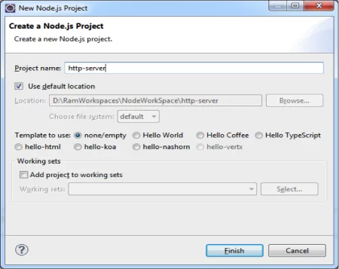](https://www.journaldev.com/wp-content/uploads/2015/05/node.js-http-server-project.png)
* Create package.json file with below contents.

package.json

{

"name": "http-server",

"version": "1.0.0",

"description": "Simple HTTP Sever",

"main": "http-server",

"author": "JournalDEV",

"engines":{

"node":"\*"

}

}

* Create a JavaScript file with the following content;

http-server.js

/\*\*

\* JournalDEV

\* Simple HTTP Server Example

\*/

var http = require("http");

var httpserver = http.createServer();

httpserver.listen(8001);

With just few lines of above code, we are able to create a simple HTTP server. Below is the explanation of different parts of the code.

* + First line, require() call loads http module into cache to use Node JS HTTP API.
  + Second line, using HTTP API we are create a Server.
  + Third line, HTTP Server listen at port number: 8001

Below image shows the project structure for now.

[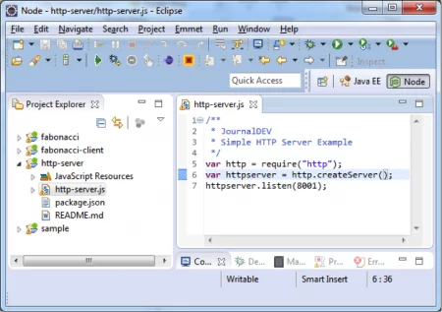](https://www.journaldev.com/wp-content/uploads/2015/05/node.js-http-server-eclipse-project.png)

* Open command prompt at ${ECLIPSE\_WORKSPACE}/http-server project and run “node http-server.js” command.  
  [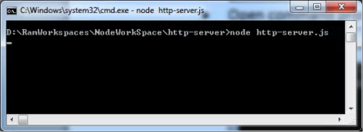](https://www.journaldev.com/wp-content/uploads/2015/05/node.js-http-server.png)

If we observe here, command is waiting for client requests that mean our simple Node JS HTTP Server is up and running successfully.

However, it cannot handle any requests with this simple HTTP Server. To handle or provide services to Client requests, we need to add some Routings. Please refer next section to extend this Basic HTTP Server program to handle client requests.

**How Node JS HTTP Server handle Client Requests**

Now we are going to add some code to receive and handle HTTP Client request.

Open http-server.js file in Eclipse IDE and add a JavaScript function to represent request and response objects.

/\*\*

\* JournalDEV

\* Simple HTTP Server Example

\*/

var http = require("http");

var httpserver = http.createServer(

function(request,response){

}

);

httpserver.listen(8001);

Here anonymous Function takes request and response as parameters. When an HTTP Client sends a request at port number 8001, this anonymous function will receive that request.

Let’s add some code to send response to the client requests.

http-server.js

/\*\*

\* Simple HTTP Server Example

\*/

var http = require("http");

var httpserver = http.createServer(

function(request,response){

console.log("Received a Client Request");

response.write("Hi, Dear JournalDEV User.")

}

);

httpserver.listen(8001);

Here when HTTP server receives a Client request, it prints a log message at server console and send a response message to the Client.  
Just start the server again in the command prompt, if the earlier server is running then you need to close and start it again.

Now open a browser and go to URL https://localhost:8001/ and you will get below response.

[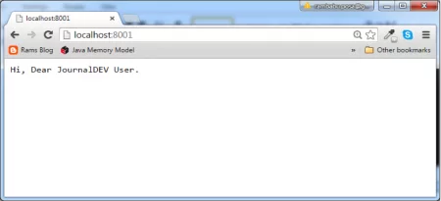](https://www.journaldev.com/wp-content/uploads/2015/05/node.js-http-server-response.png)

At the same time, you will observe server logs in the command prompt as shown below.

[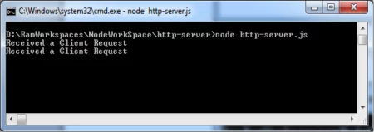](https://www.journaldev.com/wp-content/uploads/2015/05/node.js-http-server-logs.png)

**Node JS HTTP Server Routings**

So far we have developed a simple Node JS HTTP Server that just receives HTTP client request and send some response to the server. That means it handles only one kind of request: “/” when client hits this url: “https://localhost:8001”

It’s not enough to run some real-time applications with this basic HTTP Server. To handle different kinds of Client Requests, we should add “Routings” to our HTTP Server.

Create a new JavaScript file “http-server-simple-routing.js” with following content.

http-server-simple-routing.js

/\*\*

\* JournalDEV

\* Simple HTTP Server Example

\*/

var http = require("http");

var url = require('url');

var httpserver = http.createServer(

function(request,response){

var clientRequestPath = url.parse(request.url).pathname;

switch(clientRequestPath){

case '/':

console.log("Received a Client Request: Switch Case");

response.write("Hi, Dear JournalDEV User: Switch Case.");

break;

default:

console.log("Received a Client Request: Switch Default");

response.write("Hi, Dear JournalDEV User:S witch Default.");

break;

}

response.end();

}

);

httpserver.listen(8001);

Here we are using another Node JS Platform Default module: “url”. That means we don’t need to install it manually, it will come with base Node JS Platform installation.

Anonymous function with two parameters: request and response. request object contains a property: url, which contains client requested url.

Then we are calling url.parse(request.url).pathname to get client request url. Suppose if Client sends a request by using https://localhost:8001/ url, then here url.parse(request.url).pathname returns “/”.

We are saving the output of url.parse(request.url).pathname value into a local variable: clientRequestPath. We are using switch() block with one case and default blocks. If user sends request using “/”, then server executes switch:case block and send respective response to the client.

If user sends different request, then then server executes switch:default block and send respective response to the client.

We are closing the Response object using response.end() call.

Open the Command Prompt/Terminal and start the node http server “http-server-simple-routing.js” and send two different requests from client browser and observe the response.

**Case 1**: Client sends “/” request using https://localhost:8001/ url and you will see below response in browser.

[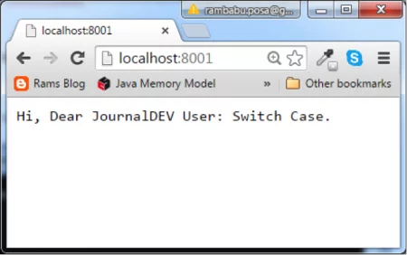](https://www.journaldev.com/wp-content/uploads/2015/05/node.js-http-server-routing.png)

**Case 2**: Client sends “/index.htm” request using https://localhost:8001/index.htm url and gets below response.

[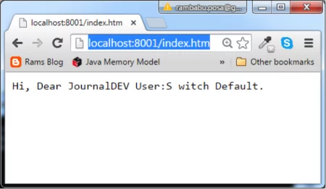](https://www.journaldev.com/wp-content/uploads/2015/05/node.js-http-server-routing-1.png)

Below image shows the server logs in these cases.

[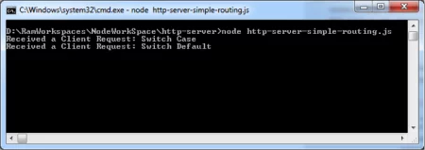](https://www.journaldev.com/wp-content/uploads/2015/05/node.js-http-server-routing-logs.png)

Here we have gone through some Routings to provide services to Client requests. We will see some more complex routings in next post “Node JS: Socket IO Module”.

To create a simple HTTP Server with simple Routings, we have written some amount of code using Node JS HTTP package. If we use Node JS Express module, then we can create similar kind of Web Servers very easily. We will see those examples in “Node JS: Express Module” in coming posts.

# Node JS Events Module and EventEmitter

We have already discussed in previous posts about Node JS Architecture. Node JS follows Event Driven Single Thread Approach. Please go through my previous posts: [“Node JS Single Threaded Event Loop Architecture”](https://www.journaldev.com/7462/node-js-architecture-single-threaded-event-loop) and [“Node JS FileSystem IO Package”](https://www.journaldev.com/7821/node-fs-js-create-file-read-write) because we are going to use FS module knowledge in this Events module examples.

We will discuss Node JS Platform “events” module and EventEmitter class with some suitable examples in this post.

**Node JS Events Module**

Node JS Platform follows Events Driven Programming model. It follows [Observer Design Pattern](https://www.journaldev.com/1739/observer-design-pattern-in-java) to handle events. In Node JS applications, every operation generates an event. And it has some Event Handlers to handle those events.

**For example:-**  
Take Node JS FS(File System) Module. When Node JS application try to open a file, then it generates an event. If it finishes reading data from a file using ReadStream, then it generates another event. If it finishes writing data to a file using WriteStream, then it generates another event. Like this for every action in Node JS Application, it generates an event.

Then, Who is responsible to generate those events? Who is responsible to handle those events? We will discuss all these questions in details soon in this post.

Like some Node modules for example “npm”, “fs” etc., Node JS “events” module is also part of basic Node JS Platform. We don’t need to do anything to setup Node JS Events module.

**Why Node JS is faster?**  
Compared to other technologies, Node JS applications provide very high performance because of this Event-Driven Programming model.

**What is EventEmitter?**  
As of today, Node JS “events” module has one and only one class to handle events: EventEmitter class. It contains all required functions to take care of generating events.

**Who is responsible to generate events in Node JS Application ?**  
EventEmitter class is responsible to generate events. Generating events is also known as Emitting. That’s why this class name is EventEmitter as it emits events in Node JS Platform.

After generating events, it places all events into Event Queue. Then Event Loop picks-up events one by one from Event Queue and process them accordingly.

**Who is responsible to handle events in Node JS Application ?**  
Node JS Platform uses the following two components to take of events.

* EventEmitter class
* Java Script Callback functions

EventEmitter class is responsible to generate events and Java Script Callback functions are responsible to handle them.

We can explain this complete process with a diagram as shown below:



* When Node JS application starts or ends an operation, EventEmitter class generates events and places them into Event Queue.
* Event Queue maintains a Queue of Events.
* Event Loop continuously waits for new events in Event Queue. When it finds events in Event Queue, it pulls them and try to process them. If they require IO Blocking operations or long waiting tasks, then assigns respective Event Handlers to handle them.
* Event Handlers are JavaScript Asynchronous Callback Functions. They are responsible to handle events and return results to Event Loop.
* Event Loop will prepare results and send them back to the Client.

First and foremost thing to start Node JS Events programming is that import “events” module as shown below:

var events = require("events");

Then use this events variable and create an object of EventEmitter class as shown below:

var eventsEmitter = new events.EventEmitter();

**EventEmitter “emit()” function**

EventEmitter class has a “emit()” function, which is used to create an Event. It takes one parameter.

eventsEmitter.emit(NameOfEventToCreate);

Here, NameOfEventToCreate: we need to pass Event Name to emit() function call as String to create that Event.

Example:-

var events = require("events");

var eventsEmitter = new events.EventEmitter();

eventsEmitter.emit("mobileon");

**EventEmitter “on()” function**

EventEmitter class has a “on()” function, which is used to bind an Event with an Event Handler JavaScript Function. It takes two parameters.

eventsEmitter.on(NameOfEventToBind, EventHandlerFuction);

Here, NameOfEventToBind: We need to pass Event Name a to on() function call as String to bind that event to given Event Handler JavaScript Function.  
and EventHandlerFuction: Given Event Handler JavaScript Function to handle that event. It may be an anonymous JavaScript function or Plain JavaScript function.

Example:-  
This example is using anonymous JavaScript function as Event Handler.

var events = require("events");

var eventsEmitter = new events.EventEmitter();

eventsEmitter.emit("mobileon",function(data){

console.log(data);

});

eventsEmitter.emit("mobileon");

We can also use Plain JavaScript function as Event Handler as shown below:

var events = require("events");

var eventsEmitter = new events.EventEmitter();

eventsEmitter.emit("mobileon",mobileOnHadler);

eventsEmitter.emit("mobileon");

function mobileOnHadler(data){

console.log(data);

}

With this knowledge about EventEmitter class, we will develop a real-time simple example to see how Node JS handles events.

**Node JS Events Example:-**

**This example demonstrates How to raise Events while Reading a File form FileSyste in Node JS Platform.**

* Create Node JS Project using Enide 2014 Studio IDE
* Copy from my previous example or Create package.json file and modify it with the following content

**package.json**

{

"name": "events",

"version": "1.0.0",

"description": "events example",

"main": "events",

"author": "JournalDEV",

"engines":{

"node":"\*"

}

}

* Create a text file “JournalDEV.txt” with the following content. We are going to use this file to test Node Js events.

**JournalDEV.txt**

Dear, JournalDEV Readers.

Thank You for your support.

* Create a JavaScript file with the following content

**events.js**

/\*\*

\* JournalDEV

\* Nodes Events Demo

\*/

var events = require("events");

var fs = require('fs');

var eventsEmitter = new events.EventEmitter();

eventsEmitter.on('read',readFileContent);

eventsEmitter.on('display',displayFileContent);

eventsEmitter.on('finished',finished);

eventsEmitter.emit('read','JournalDEV.txt');

function readFileContent(fileName){

console.log("Reading " + fileName + " file started:");

fs.readFile(fileName, 'utf8', readFile);

}

function displayFileContent(data){

console.log("File Data:");

console.log(data);

eventsEmitter.emit('finished');

}

function finished(){

console.log("Reading and Printing File content job is done successfully.");

}

function readFile(err,data,fileName) {

console.log("Reading " + fileName + " file done successfully.");

eventsEmitter.emit('display',data);

}

**Code exaplanation:**

* 1. At line no:5-6, we have imported Node JS “events” and “fs” (FileSystem) module into our application cache.
  2. At line no:7, we have created an object of EventEmitter class
  3. At line no:15-33, we have written JavaScript functions. We use them as Event Handler Functions.
  4. At line no:9, we have binded “read” event with “readFileContent” Event Handler function using on() method of EventEmitter class.
  5. At line no:10, we have binded “display” event with “displayFileContent” Event Handler function using on() method of EventEmitter class.
  6. At line no:11, we have binded “finished” event with “finished” Event Handler function using on() method of EventEmitter class.
  7. At line no:12, we have raised a “read” event by passing filename “JournalDEV.txt” as input using emit() method of EventEmitter class.
* Final Project structure will looks like this:

[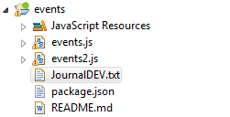](https://www.journaldev.com/wp-content/uploads/2015/05/nodejs-events-project.png)

**NOTE:-**Please ignore “events2.js” file. That is back file for my future reference.

* Run this JavaScript file and observe the output at Enide 2014 Studio IDE Console

[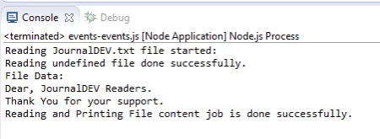](https://www.journaldev.com/wp-content/uploads/2015/05/nodejs-events-output.png)

By observing this output, we are successfully raised some events while reading a file and handled them propertly.

That’s it about Node JS Events Module.

# Express JS and Express Generator Module Basics, Express JS Sample WebApplication

As we discussed in my initial Node JS Platform posts, Node JS has many modules to develop different kinds of functionality. Each Node JS Module is aimed to provide one or more kinds of services. Like other modules or packages, Express JS is also a module in Node JS Platform.

In this post, we will discuss some basics of “Node: Express JS Module”. As it is very big and important module in Node JS Platform, we will discuss some advanced concepts of Express JS module in coming posts.

**What is Express JS**

Express JS is a Light-weight Web Framework to develop Web Applications very easily and quickly in Node JS Platform.

Express JS Official Website: https://expressjs.com/

In previous section  “Node JS HTTP Module”, we have developed an HTTP Server using Node JS “http” module. We can develop similar kind of HTTP Server or WebServer using Express JS Module too.  
We will discuss on “How to develop a WebServer using Express JS Module” in coming posts.

**Express JS Features**

Express JS Framework provides the following features

* Light-weight Web Application Framework
* It Supports Routings
* It supports Template Engines
* It supports File Uploading
* Develop SPA(Singe Page WebApplications)
* Develop Real-time Applications

**NOTE:-**  
Node JS: HTTP Module is basic module to develop HTTP based Networking applications. Node JS: Connect Module is developed on top of HTTP module to provide some extract features like Cookies, Middleware,CSRF etc. Node JS: Express module is developed on top of “Connect” module to provide some more additional features on top of HTTP and Connect Modules.

**Express JS Setup**

Unlike some Node JS Default Modules like “npm”,”http”,”events” come with Node JS Platform basic installation (No need of separate steps to install these modules), Express JS does not come with as Node JS Default modules. We need to install it manually.

We have already discussed on “How to install a Node JS Module” using “node install” command. If you are not familiar about this command, please go through my previous post : “NPM install update and uninstall example”

**To install Express JS globally**  
Before staring Express JS Development, first and fore most step We need to do is use “npm install” command to install Express JS module

npm install -g express

Here “express” means Express JS Module and “-g” means install Express JS Module globally.

Open command prompt and execute above command to install Express JS Module globally.

[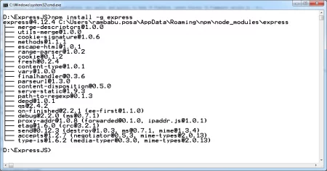](https://www.journaldev.com/wp-content/uploads/2015/06/expressjs_install.png)

**To verify installation**

After Express JS installation is done, we need to check whether this module is installed successfully or not. If it is installed successfully, we can find a new folder at  
C:\Users\[Windows\_USerName]\AppData\Roaming\npm\node\_modules\express

[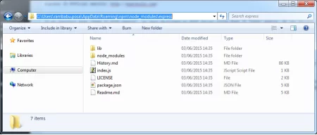](https://www.journaldev.com/wp-content/uploads/2015/06/expressjs_install_success.png)

Here we are able to see “express” folder under “node\_modules” folder. That means our Express JS is installed successfully.

Node JS Platform has another module : “express-generator”. Earlier “express-generator” module is part of “express” module only. But to provide clear modularity, they have separated into two modules.

**What is Express Generator**

Like Express JS, Express Generator is also a Node JS Module. It is used to quick start and develop Express JS applications very easily. It does not come as part of Node JS Platform basic installation. We need to install it manually.

**To install Express JS globally**  
Open command prompt and execute this command: npm install -g express-generator

[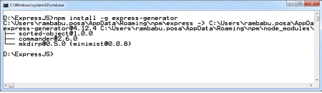](https://www.journaldev.com/wp-content/uploads/2015/06/express_generator_install.png)

**To verify installation**  
After Express Generator installation is done, we need to check whether this module is installed successfully or not.

[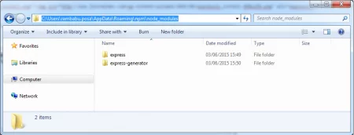](https://www.journaldev.com/wp-content/uploads/2015/06/express_generator_install_success.png)

Here we are able to see “express-generator” folder under “node\_modules” folder. That means our Express Generator is installed successfully.

**Express JS Simple WebApplication Example**

We are going to develop simple Express JS WebApplication using Express Generator Module. We are really NOT developing this application from the scratch, just taking Express Generator help.

Please follow these steps to develop and run simple Express JS WebApplication:

* First install both Node JS Modules: “express” and “express-generator”. We have already done it.
* Open command prompt in our local FileSystem and execute the “express” command.

**“express” command syntax:**

express <Your-ExpressJS-Application-Name>

**Example:**

express ExpressSampleWebApp

[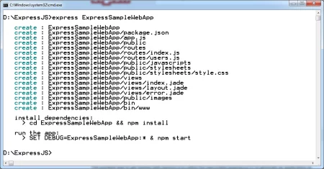](https://www.journaldev.com/wp-content/uploads/2015/06/express_sample_webapp.png)

If we observe this screenshot, “express” command has downloaded a sample Express JS WebApplication with given Application name. It also displays two instructions at the end of the log.

* 1. cd ExpressSampleWebApp && npm install

It instructs us use “cd” command to move to our application folder and build our application by executing “npm install” command

* 1. SET DEBUG=ExpressSampleWebApp:\* & npm start

It instructs us set debut mode if required and execute “npm start” command to start our application.

Now if we access our application folder , we can see the following content.

[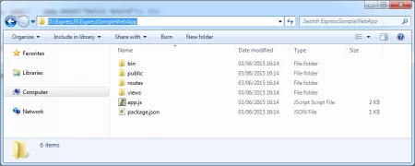](https://www.journaldev.com/wp-content/uploads/2015/06/express_sample_webapp_content.png)

* Execute above two commands one by one from command prompt

**To install (build) our application:**

npm install

[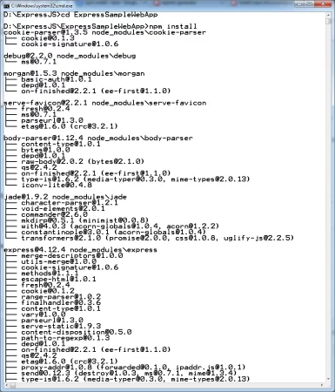](https://www.journaldev.com/wp-content/uploads/2015/06/express_sample_webapp_install.png)

**To start our Express application:**

npm start

[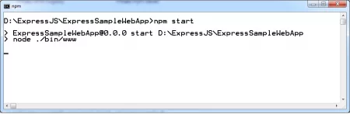](https://www.journaldev.com/wp-content/uploads/2015/06/express_sample_webapp_start.png)

* Access Express JS Sample WebApplication using https://localhost:3000/ from our browser.

[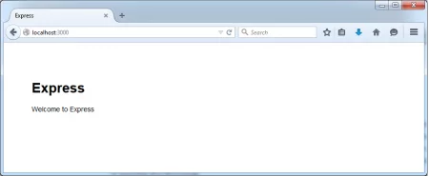](https://www.journaldev.com/wp-content/uploads/2015/06/express_sample_webapp_output.png)

When we execute “npm start” command, by default it starts Express JS WebServer at 3000 port number and deploy our Express JS Application into server.

It is very easy right to develop a simple Express JS WebApplication using Express Generator module. From this point, we can add our required components and code to improve this application functionality.

Here we have developed just sample Express Application without using any Tools or IDEs. In my upcoming posts, we will discuss on “How to develop Express JS Applications using Eclipse Enide 2014 IDE”.

That’s it about Express JS Basics. If you have queries, please drop me a comment.

# Express JS WebApplication with Enide Studio 2014 IDE

In my previous post, we have discussed about [“Express JS and Express Generator Basics, Express JS Sample WebApplication”](https://www.journaldev.com/7993/nodejs-express-js-and-express-generator-module-basics). In that post, we have not used any Node IDE to develop application. We have developed that application using Express Generator module.

Express Generator is a Node JS Module related to Express JS Framework. It is used to get start the development of Express JS WebApplication in few minutes.

In this section, we are going to develop same Express JS WebApplication using Enide Studio 2014 Node IDE.

Before starting Express JS WebApplication development, first we need to install Express JS module. Please refer my previous post to Install and Basics of Express JS Module.

**Express JS WebApplication and Routings with Enide 2014 IDE**

We will develop a Express JS WebApplicaiton with some useful Routings using Enide 2014 IDE. So for we have create “Node.js Project” using Enide Studio 2014 IDE. But now we need to create Node.js Express Project. Please select “Node.js Project” rom “New” wizard. Click on “Next” button.

* Please create a “Node.js Express JS Project”(Please refer my previous post to get more information about “[How to use Enide Studio 2014 IDE](https://www.journaldev.com/7527/node-js-basic-examples-with-node-cli-and-node-ide)“)

[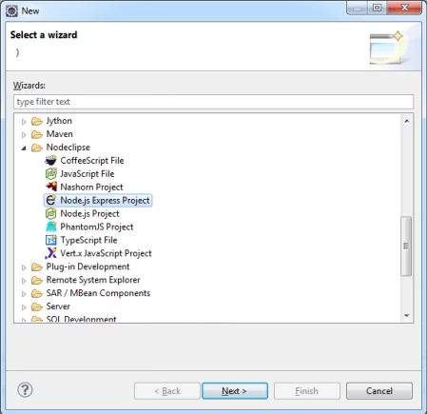](https://www.journaldev.com/wp-content/uploads/2015/06/nodejs-express-project.png)

Provide our Express JS WebAppilcation name “expressjs” and click on “Finish” button.

[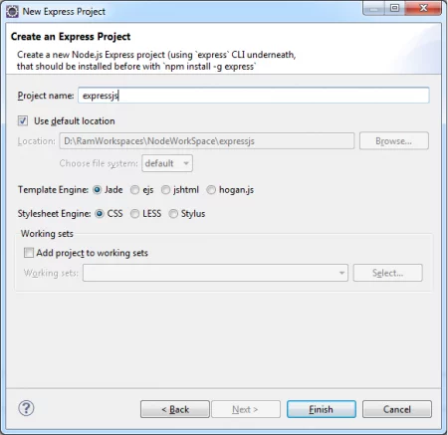](https://www.journaldev.com/wp-content/uploads/2015/06/nodejs-express-projectname-engine.png)

If we observe this screenshot, this wizard will select the following two default options

* 1. Express JS Framework Template Engine: Jade
  2. Express JS Framework CSS(Stylesheet) Engine: CSS

**NOTE:-** Jade is a Template Engine framework. Using Jade, We can develop HTML pages very easily and quickly. All Jade Template files have “.jade” file extension.Please refer some online articles on Jade Framework.

Express JS Sample WebApplication places

* 1. All Jade Templates under /${ExpressJS\_Project\_ROOT\_DIR}/views/\*.jade.
  2. All CSS fukes under /${ExpressJS\_Project\_ROOT\_DIR}/public/stylesheets/\*.css.

These are default folder options. We can change them as per our Project requirements but update them in all \*.js files accordingly.

* Enide Studio 2014 IDE will create a Express JS WebAppilcation Project structure looks like this

[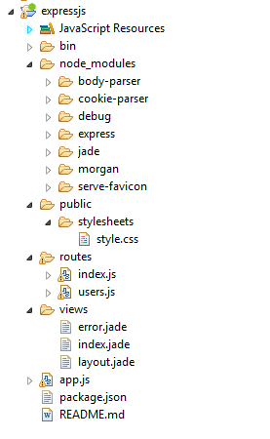](https://www.journaldev.com/wp-content/uploads/2015/06/nodejs-express-project-structure.png)

* It automatically creates package.json file with the following content

**package.json**  
  
{  
“name”: “expressjs”,  
“version”: “0.0.0”,  
“private”: true,  
“scripts”: {  
“start”: “node ./bin/www”  
},  
“dependencies”: {  
“body-parser”: “~1.12.4”,  
“cookie-parser”: “~1.3.5”,  
“debug”: “~2.2.0”,  
“express”: “~4.12.4”,  
“jade”: “~1.9.2”,  
“morgan”: “~1.5.3”,  
“serve-favicon”: “~2.2.1”  
}  
}

* It downloads all required Node JS modules under “node\_modules” folder as shown below.

[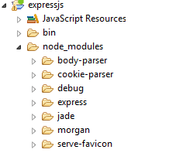](https://www.journaldev.com/wp-content/uploads/2015/06/nodejs-express-nodemodules.png)

* It automatically creates a main app.js file at Project root directory.

**To create Express JS Application**  
  
var express = require(‘express’);  
var expressApp = express();

We can use require(“express”) call to load Express JS module into our Node JS Application memory.

* Execute the application and observe the output

Open command prompt at Project root folder and start the application using the following command:

npm start

[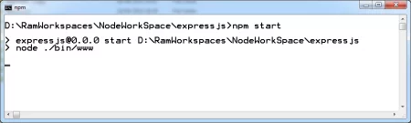](https://www.journaldev.com/wp-content/uploads/2015/06/nodejs-express-execute.png)

Now our Express JS WebApplication is up and running. It’s time to access this application using this url: https://localhost:3000.

[](https://www.journaldev.com/wp-content/uploads/2015/06/express_sample_webapp_output.png)

Now we are able to see our WebApplication output.

* Observe Express JS WebServer console

When we access our Express JS WebApplication using https://localhost:3000 url, Web Browser sends a HTTP GET request to Server. Server receives this HTTP GET request, processes the Client request, generates the response and send the response back to Web Browser.

We can observe this at WebServer console as shown below:

GET / 200 283.840 ms - 170

[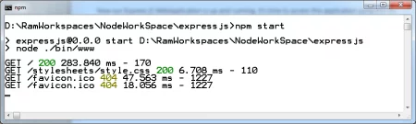](https://www.journaldev.com/wp-content/uploads/2015/06/nodejs-express-server-console.png)

Here GET is HTTP GET request method, “/” means client requested this url and “200” is “Success” response code.

Like [“Express JS and Express Generator Basics, Express JS Sample WebApplication”](https://www.journaldev.com/7993/nodejs-express-js-and-express-generator-module-basics) post, here also we have created similar Sample Express JS WebApplicaiton. But using Enide Studio 2014 IDE.

We will discuss about “How Express JS deals with Routings” in my coming post.

# Express JS Routings with Enide Studio 2014 IDE

This post is a continuation post of my previous post “[Express JS WebApplication with Enide Studio 2014 IDE”](https://www.journaldev.com/8249/express-js-webapplication-with-enide-studio-2014-ide). In my previous post, we have discussed about “How to create a Express JS WebApplication with Enide Studio 2014 IDE”. We have just created and discussed about some code snippets. We have not discussed about Express JS Routings.

We are going to discuss Express JS Routings in this post in details. Before reading this post “Express JS WebApplication with Enide Studio 2014 IDE”, please refer my previous post and create Express JS WebApplication.

**Brief Steps To Create Express JS Routings**

Here I’m going to give you the steps to follow to create Routings in Express JS WebApplication. First, We will discuss each step in detail with Enide Studio 2014 IDE Default “Node:Express JS Project”. Then we will discuss about how to create our own Express JS Routings in coming sections.

* Create Routings
* Create Views
* Load all newly created Routing files into Variables in app.js
* Map Client Requested URLs to Routings in app.js
* Start Application and Test Routings

**Explore Default Express JS Routings**

When we create Express JS Sample WebApplication using Enide Studio 2014 IDE, it creates a **“app.js”** file at Project root directory. This is the starting point to access Express JS Application.

* First load “express” module into our application cache and create Express JS Application as shown below

var express = require('express');

var app = express();

* It places all Express JS Routing files under “${EXPRESSJS\_PROJECT\_ROOT\_DIR}\routes” folder

Our “expressjs” project contains default two routing files: index.js and users.js

* It places all Express JS View files under “${EXPRESSJS\_PROJECT\_ROOT\_DIR}\views” folder

As Default “Node JS: Express JS Project” uses JADE as default Template Engine, it creates jades as views at this location.  
This project contains default three views: index.jade, layoug.jade and error.jade

**NOTE:-** JADE is simple and very powerful Template Engine Framework to Design and Develop HTML pages very easily. Please refer some online tutorials on this Framework. I will try to give one to two posts on this JADE framework after sometime.

* Explore Routings in index.js

**index.js**

var express = require('express');

var router = express.Router();

/\* GET home page. \*/

router.get('/', function(req, res, next) {

res.render('index', { title: 'Express' });

});

module.exports = router;

**Code Explanation**

* 1. Line 1, Loaded Express JS Module into our application cache and stored it into a variable “express”
  2. Line 2, use Router class to create a router object. We use “express” variable to create Router object: ” express.Router()”
  3. Line 5-7, using “router” object, we have created a function to handle HTTP GET Requests
  4. Line 6, it is very important because here we wrote our Routings. When Client or WebBrowser sends request using “/” (That is https://localhost:3000/) using HTTP GET Request method, then it comes to this function and route the controller to the “index” view. It is automatically mapped to “index.jade” and populate “title” attribute with ‘Express’ value (Please refer below index.jade file).

**index.jade**

extends layout

block content

h1= title

p Welcome to #{title}

That’s why when we access our application using “https://localhost:3000/”, we got the following output showing this “title” attribute value as ‘Express’.

[](https://www.journaldev.com/wp-content/uploads/2015/06/express_sample_webapp_output.png)

**NOTE:-** I guess you all are already familiar with Spring MVC or Struts Frameworks. Even in these frameworks also, we do similar kind of Routings right.

* 1. Line 9, we have exported our router object to be used in other modules in the Same or different Projects.
* Explore Routings in users.js

**users.js**

var express = require('express');

var router = express.Router();

/\* GET users listing. \*/

router.get('/', function(req, res, next) {

res.send('respond with a resource');

});

module.exports = router;

It is just duplication of index.js file but it does NOT map to any view here. We are just sending a response text ‘respond with a resource’ to the Client or Browser.

If we access the same application with “https://localhost:3000/users”, then we will get the following output on Browser:

[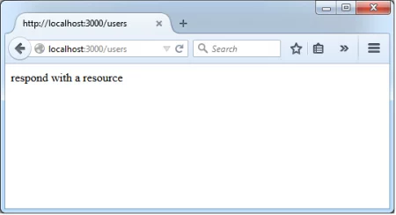](https://www.journaldev.com/wp-content/uploads/2015/06/expressjs_webapp_users_output.png)

* Explore app.js

Once we have developed both Views and Routes, now it’s time to map them. We need to map them in app.js file. This is very important and staring point for a Node:Express JS application. When we execute “npm start” command from Command Prompt at Project Root Directory, it searches for “app.js” file. Then it loads all project files into Server and waits for Client Requests.

Now we will see how to map these files in “app.js” file in step by step.

* 1. First step is loading our Routing files into variables as shown below

var routes = require('./routes/index');

var users = require('./routes/users');

Like loading other Node JS Module into our Project Cache, We use require() call to load our Routing files into variables .

* 1. Map URLs to these Routing variables as shown below using “app” Express JS Application Object.

app.use('/', routes);

app.use('/users', users);

That means, when Client or WebBroswer sends request to our “Node:Express JS” Application, then application maps those URLs to Hadlers as shown below

**https://localhost:3000/**

https://localhost:3000/ --> It maps to app.use('/', routes);

app.use('/', routes); --> It in turn maps to './routes/index.js'

Then finally, it executes Functions defined in index.js

Prepare Views and send that Response back to the Client

Similarly, **https://localhost:3000/users**

https://localhost:3000/users --> It maps to app.use('/users', users);

app.use('/users', users); --> It in turn maps to './routes/users.js'

Then finally, it executes Functions defined in users.js

Prepare Views and send that Response back to the Client

**Create New Express JS Routings**

So far we have explored about Default Routings. To make it clear, we will create some new Routings.  
We are going to provide the following CRUD operations Routings on USER domain object. We are not going to write much logic to perform any DB logic. We are just displaying some message.

/create ----> createUser.js

/select ----> selectUser.js

/delete ----> deleteUser.js

/update ----> updateUser.js

Please follow these steps to “Create New Express JS Routings”:

* Please create new Routing Files under “${EXPRESSJS\_PROJECT\_ROOT\_DIR}\routes” folder

**createUser.js**

var express = require('express');

var router = express.Router();

/\* GET users listing. \*/

router.get('/', function(req, res, next) {

res.send('User Created Successfully.');

});

module.exports = router;

**selectUser.js**

var express = require('express');

var router = express.Router();

/\* GET users listing. \*/

router.get('/', function(req, res, next) {

res.send('Retrieved User Details Successfully.');

});

module.exports = router;

**deleteUser.js**

var express = require('express');

var router = express.Router();

/\* GET users listing. \*/

router.get('/', function(req, res, next) {

res.send('User Deleted Successfully.');

});

module.exports = router;

**updateUser.js**

var express = require('express');

var router = express.Router();

/\* GET users listing. \*/

router.get('/', function(req, res, next) {

res.send('User Updated Successfully.');

});

module.exports = router;

* Create New View files

In real-time projects, we need to create some HTML Page or JADE templates or any Views for each Routings. However, for simplicity We are not going to write much logic.  
We are just using some useful message from Routing Function handler as shown in above step.

* Load all newly created Routing files into Variables as shown below in app.js

var createUser = require('./routes/createUser');

var selectUser = require('./routes/selectUser');

var deleteUser = require('./routes/deleteUser');

var updateUser = require('./routes/updateUser');

* Map Client Requested URLs to Routings in app.js

app.use('/', routes);

app.use('/users', users);

app.use('/create', createUser);

app.use('/select', selectUser);

app.use('/delete', deleteUser);

app.use('/update', updateUser);

* Now its time to start our Express JS WebApplication to test our newly created Routings.

Open command prompt at our project ROOT Directory and execute the following command:

npm start

[](https://www.journaldev.com/wp-content/uploads/2015/06/nodejs-express-execute.png)

* Access the URLs and observe the output console.

Access this url: **https://localhost:3000/create**

[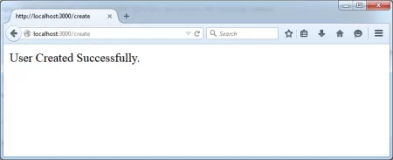](https://www.journaldev.com/wp-content/uploads/2015/06/expressjs_webapp_create_user_output.png)

Access this url: **https://localhost:3000/select**

[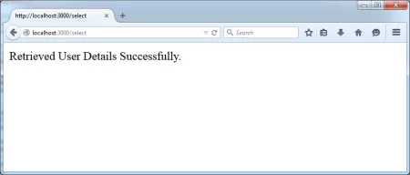](https://www.journaldev.com/wp-content/uploads/2015/06/expressjs_webapp_select_user_output.png)

Similarly, we can test all our Express JS Routings.

That’s it about Express JS Routings. By using Enide Studio 2014 IDE Default “Node:Express JS Project”, We can update or add our requirements and can implement very big and real-time application.

Try to implement one real-time application.

Please drop a comment if you face any issues.

# Node Express JS: Socket IO Module Example

Before reading post, please go through my previous posts: [“Express JS WebApplication with Enide Studio 2014 IDE”](https://www.journaldev.com/8249/express-js-webapplication-with-enide-studio-2014-ide) and [“Express JS Routings with Enide Studio 2014 IDE”](https://www.journaldev.com/8282/express-js-routings-with-enide-studio-2014-ide).

**Introduction to Socket IO**

Node JS: Socket IO Module is used to develop Real-time Client-Server Communication applications. It internally uses “WebSocket” Programming model to provide real-time two-way communication between Client and Server.

We can observe that the following Technologies offer WebSocket Programming to implement this kind of applications.

1. HTML5 WebSocket
2. Java EE 7 WebSocket API
3. Node JS:Socket IO Module

**Difference between Traditional HTTP and WebSocket Approaches**

**Traditional HTTP Approach:**  
We have our old and Traditional HTTP Request-Response Stateless Approach to provide Communication between Client and Server. But it follows “Pushing” model that means when client sends a request to Server, Server pushes the response to the Clients.

**WebSocket Approach:**  
We can use WebSocket Approach too to provide Communication between Client and Server. However unlike Traditional HTTP Request-Response Stateless Approach, WebSocket Approach provides Communication between Client and Server by using “Pulling” model that means Server always pulls data to Clients. That’s why is is more efficient and faster approach to provide Client-Server Communication.

**Advantages of Socket IO(WebSocket) Programming:**

1. Faster and Two-way Communication
2. Cross-Browser Support
3. Cross-Platform Support
4. Platform independent web framework

**Socket IO Setup**

Unlike some Node JS Default Modules like “npm”,”http”,”events” come with Node JS Platform basic installation (No need of separate steps to install these modules), Socket.IO does not come with as Node JS Default modules. We need to install it manually.

We have already discussed on “How to install a Node JS Module” using “node install” command. If you are not familiar about this command, please go through my previous post : “NPM install update and uninstall example”

**To install Socket.IO globally**  
Before staring Express JS Development, first and fore most step We need to do is use “npm install” command to install Express JS module

npm install -g socket.io

Here “socket.io” means Socket IO Module and “-g” means install Socket.io Module globally.

**To verify installation**

After Socket IO Module installation is done, we need to check whether this module is installed successfully or not. If it is installed successfully, we can find a new folder at  
C:\Users\[Windows\_USerName]\AppData\Roaming\npm\node\_modules\socket.io as shown below:

[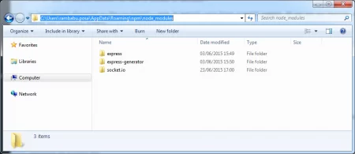](https://www.journaldev.com/wp-content/uploads/2015/06/socketio_install.png)

**Socket IO Example**

* Create a Node.js:Express JS Project with default settings: “socketio” (Please refer my previous post “[Express JS WebApplication with Enide Studio 2014 IDE](https://www.journaldev.com/8249/express-js-webapplication-with-enide-studio-2014-ide)” for more details.)
* Update “package.json” file with “socket.io” module dependency.

**Default package.json**

{

"name": "socketio",

"version": "0.0.0",

"private": true,

"scripts": {

"start": "node ./bin/www"

},

"dependencies": {

"body-parser": "~1.12.4",

"cookie-parser": "~1.3.5",

"debug": "~2.2.0",

"express": "~4.12.4",

"jade": "~1.9.2",

"morgan": "~1.5.3",

"serve-favicon": "~2.2.1"

}

}

**Updated package.json**

{

"name": "socketio",

"version": "0.0.0",

"private": true,

"scripts": {

"start": "node ./bin/www"

},

"dependencies": {

"body-parser": "~1.12.4",

"cookie-parser": "~1.3.5",

"debug": "~2.2.0",

"express": "~4.12.4",

"jade": "~1.9.2",

"morgan": "~1.5.3",

"serve-favicon": "~2.2.1",

"socket.io": "~1.3.5"

}

}

* Observe default “node\_modules” folder

If we observe our project now, it contains all default Express JS Module libraries as shown below:

[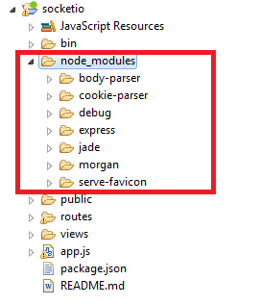](https://www.journaldev.com/wp-content/uploads/2015/06/socketio_default_node_modules.png)

* Update “node\_modules” with “socket.io” library.

In order to use Socket IO module library, we need to execute the following command at our project root directory:

npm install --save socket.io

Here “–save” option means retrieve “socket.io” library from our Local repository and add this to our project. This is something similar to adding JAR files to our Java Project.

Open command prompt at our project root directory and execute above command:

[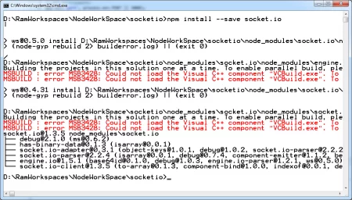](https://www.journaldev.com/wp-content/uploads/2015/06/socketio_npm_insatll_save_command.png)

**NOTE:-** Please ignore those errors or warnings.

Now refresh your “socketio” project in Enide IDE Studio 2014 IDE and observe newly added socketio library to our project as shown below:

[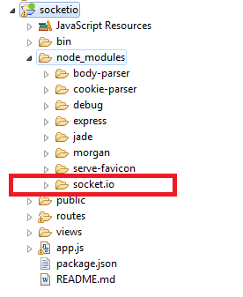](https://www.journaldev.com/wp-content/uploads/2015/06/socketio_updated_node_modules.png)

* Update app.js with the following content:

**app.js**

// Required Modules

var express = require('express');

var path = require('path');

var http = require('http');

var favicon = require('serve-favicon');

var logger = require('morgan');

var cookieParser = require('cookie-parser');

var bodyParser = require('body-parser');

var io = require('socket.io');

// Routings

var index = require('./routes/index');

var user = require('./routes/users');

// Create Express App

var app = express();

app.set('port', process.env.PORT || 3000);

//view engine setup

app.set('views', path.join(\_\_dirname, 'views'));

app.set('view engine', 'jade');

app.use(logger('dev'));

app.use(bodyParser.json());

app.use(bodyParser.urlencoded({ extended: false }));

app.use(cookieParser());

app.use(express.static(path.join(\_\_dirname, 'public')));

app.use('/', index);

app.use('/users', user);

var server = http.createServer(app);

io.listen(server);

io.sockets.on('connection', function (socket) {

socket.on('messageChange', function (data) {

console.log(data);

socket.emit('receive', data.message.split('').reverse().join('') );

});

});

server.listen(app.get('port'), function(){

console.log('Express server listening on port ' + app.get('port'));

});

module.exports = app;

**Code Explanation**

* 1. Line No 1-9, importing all required dependency Node JS modules into our application
  2. Line No 12-13, importing Routings into our application
  3. Line No 16, Create Express JS Application object
  4. Line No 17, Set Express WebServer port to listen. This is how we can set our desired port number.
  5. Line No 20-21, Define our application View Template Engine i.e. JADE
  6. Line No 33, Create an HTTP Server
  7. Line No 34, Wrap HTTP Server with Socket IO(WebSocket)
  8. Line No 36-41, io.sockets.on() to open a WebSocket connection between Client and Server.
  9. Line No 47, Export our application.
* Update index.jade file with the following content:

**/views/index.jade**

extends layout

block content

h1= title

p Welcome to

span.received-message #{example}

input(type='text', class='message', onkeyup='send(this)')

script(src="/socket.io/index.js")

script.

var socket = io.connect('https://localhost');

socket.on('receive', function (message) {

console.log('received %s', message);

document.querySelector('.received-message').innerText = message;

});

function send(input) {

console.log(input.value)

var value = input.value;

console.log('Sending Client Message: %s to Server', value);

socket.emit('messageChange', {message: value});

}

* Update index.js file with the following content:

**/routes/index.js**

var express = require('express');

var router = express.Router();

/\* GET home page. \*/

router.get('/', function(req, res, next) {

res.render('index', { example: 'Node Express JS: Socket.IO Module',

title: 'Socket.IO Module' });

});

module.exports = router;

* Final project structure looks like this:

[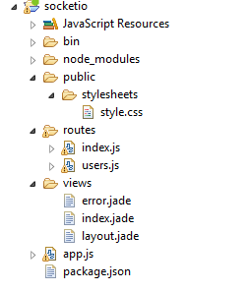](https://www.journaldev.com/wp-content/uploads/2015/06/exress_socketio_project_structure.png)

**Execute Socket IO Example**

* Open command prompt at our project root directory and execute below command:

npm start

[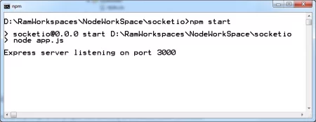](https://www.journaldev.com/wp-content/uploads/2015/06/express_socketio_run.png)

* Run Socket IO Example and observe the output

Access application using this URL: https://localhost:3000/

[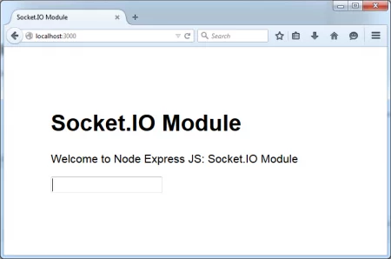](https://www.journaldev.com/wp-content/uploads/2015/06/express_socketio_output1.png)

To see WebSocket power Internally, please use Mouse Right Click and Select “Inspect Element” as shown below:

[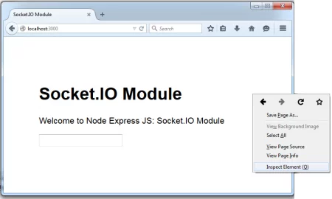](https://www.journaldev.com/wp-content/uploads/2015/06/express_socketio_output2.png)

Select “Console” tab. Type some text in “Textbox” and observe the Console output as shown below:

[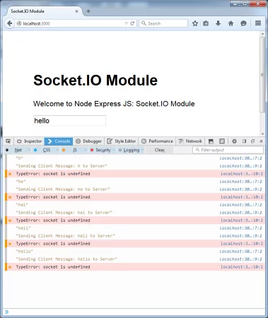](https://www.journaldev.com/wp-content/uploads/2015/06/express_socketio_output3.png)

Our application sends each and every character immediately to server. That’s the beauty of WebSocket Programming.

That’s it about Express: Socket IO Module Example.

In my next post, I will give you another Socket IO Module example without using Express JS WebFramework.

# Integration of Node JS and MongoDB Simple Example

In this post, we will discuss about how to integration Node JS Platform with MongoDB NoSQL Database and develop simple Node MongoDB Application.

### Introduction to Node JS and MongoDB

We are already familiar with Node JS Platform. If you are new to Node JS, please go through my Node JS Basics posts.

MongoDB is Cross-Platform Document-Based, High Performance and Highly Scalable No SQL Data Store from MongoDB Inc. (formerly known as 10gen). It stores data in the form of Documents. To install and learn basics of MongoDB, please refer MongoDB Tutorial.

### Node JS :MongoDB Setup

We should use “mongodb” Node JS module to develop Node JS Applications using MongoDB NoSQL Data Store. As this module is not a Default Node JS Module, we need to install this package using NPM (Node Package Manager).

To install “mondgodb” module:

npm install -g mongodb

Here option “-g” means install this package globally and “mongodb” means install Node JS MongoDB module.

[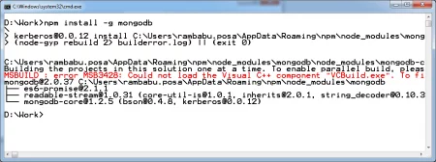](https://www.journaldev.com/wp-content/uploads/2015/07/node-mongodb-install-output.png)

Here ignore Errors. Those are related to some Windows OS and does not effect our Node JS Platform development.

Now Observe Node “mongodb” module in our local NPM Repository as shown below.

[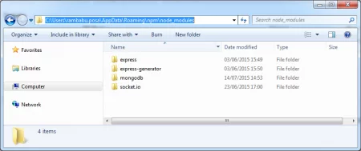](https://www.journaldev.com/wp-content/uploads/2015/07/node-mongodb-install.png)

Here we can observe new “mongodb” folder is added at “/node\_modules” that means our installation is done successfully.

### Node JS and MongoDB Example

Node JS and MongoDB setup is done. Now it’s time to develop a simple application to store data in MongoDB Store using Node JS Scripts. Like my previous examples, we use Enide Studio 2014 IDE to develop this application.

* Create a Node JS Project in Enide IDE.

Project Name : “node-mongodb”

NOTE:- Now on-wards, We will refer “PROJ\_ROOT\_DIR” value as follows

${PROJ\_ROOT\_DIR} = D:\RamWorkspaces\NodeWorkSpace\node-mongodb

* Copy package.json file from my previous examples and updated it with the following content

**package.json**

{

"name": "node-mongodb",

"version": "1.0.0",

"private": true,

"scripts": {

"start": "node node-mongodb.js"

},

"dependencies": {

"mongodb": "~2.0"

}

}

**NOTE:-**

* 1. As I have installed MongoDB 2.6 in my Windows 7 System, I’m refering “~2.0” value to Node: MongoDB Module. It should match to our mongodb module version.
  2. When I install “npm install -g mongodb”, it creates a “package.json” file at “node\_modules/mongodb” folder

In my system, it has created at “C:\Users\rambabu.posa\AppData\Roaming\npm\node\_modules\mongodb” folder as shown below

[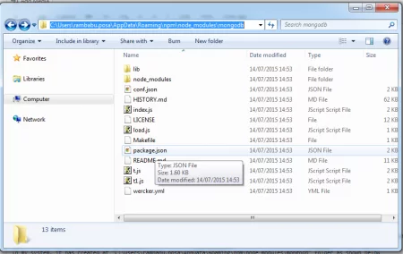](https://www.journaldev.com/wp-content/uploads/2015/07/node-mongodb-package.json_.png)

When we open this “package.json” file, you will find the following version for Node: MongoDB Module

{

"name": "mongodb",

"version": "2.0.37",

...

}

That’s why we are using “mongodb” module version as **“~2.0”** in our project’s “package.json” file.

* Add “mongodb” module library to our project.

Open command prompt at ${PROJ\_ROOT\_DIR}

Install “npm install –save mongodb” command to

Here option “–save” means pickup “mongodb” module library from our local NPM modules (C:\Users\rambabu.posa\AppData\Roaming\npm\node\_modules) and add that library to our project.

[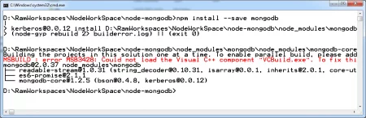](https://www.journaldev.com/wp-content/uploads/2015/07/add-mongodb-library-project.png)

If we refresh our project in Enide IDE, we can observe that “mongodb” library was added to the project build path as shown below:

[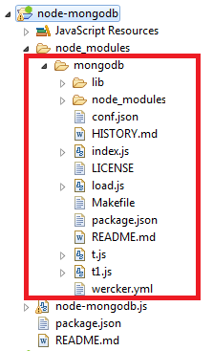](https://www.journaldev.com/wp-content/uploads/2015/07/node-mongodb-libs1.png)

* Create a “node-mongodb.js” JavaScript file and update it the following content

**node-mongodb.js**

var mongodb = require('mongodb');

var mongoClient = mongodb.MongoClient;

var url = 'mongodb://localhost:27017/jdproject';

mongoClient.connect(url, function(err, db) {

createDocuments(db, function() {

db.close();

});

});

var createDocuments = function(db, callback) {

var collection = db.collection("jduser");

collection.insert([

{firstname : "Rams",lastname: "Posa",emailid: "rams@journaldev.com"},

{firstname : "Mani",lastname: "Nulu",emailid: "mani@journaldev.com"},

{firstname : "Bhargs",lastname: "Nulu",emailid: "Bhargs@journaldev.com"},

], function(err, result) {

callback(result);

});

}

#### Code Explanation

* 1. Line No: 1, Loaded our project dependency module “mongodb” into our project memory.
  2. Line No: 2, Using “mongodb” object created at Line No:1, we have create MongoDB Client.
  3. Line No: 4, It is a MongoDB Connection URL. It’s format is :

mongodb://[hostname]:[mongodb-server-port-number]/[mongodb-dbname]

Example:-

mongodb://localhost:27017/jdproject

Here host is “localhost”  
MongoDB Default port number is “27017”  
My project MongoDB dbname is “jdproject”

* 1. Line No: 6-10, Created MongoDB Connection using MongoDB Connection URL and making a call to “createDocuments” function.
  2. Line No: 12-21, Defined a “createDocuments” function.

“createDocuments” function does the following things:

Line No: 13, Creating a “jduser” MongoDB Collection.  
Line No: 14-20, Inserting 3 MongoDB Documents using “collection.insert()” function call into “jduser” MongoDB Collection.

* Our final Project structure looks like this:

[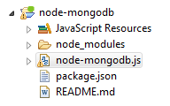](https://www.journaldev.com/wp-content/uploads/2015/07/node-mongodb-proj-structure.png)

* Test our Node-MongoDB Application

Start MongoDB Server as shown below (My MongoDB is installed at “D:\MongoDB2.6”)

mongod --config D:\MongoDB2.6\mongo.config

[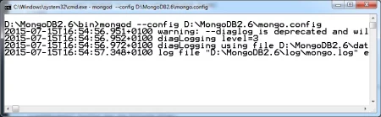](https://www.journaldev.com/wp-content/uploads/2015/07/start-mongodb-server.png)

Connect to MongoDB Client and check current DBs as shown below

show dbs;

[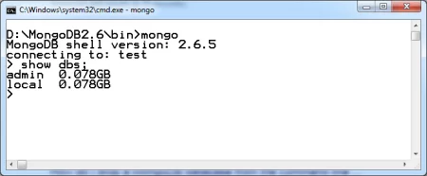](https://www.journaldev.com/wp-content/uploads/2015/07/mongodb-default-dbs.png)

Here we can observe only two default MongoDB Databases.

Open CMD Prompt at ${PROJ\_ROOT\_DIR} and run our “node-mongodb.js” application as shown below

node node-mongodb.js

[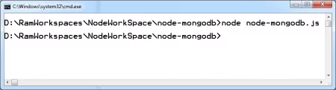](https://www.journaldev.com/wp-content/uploads/2015/07/node-mongodb-proj-execute.png)

Now go to MongoDB Client and execute “show dbs” command and observe newly created “jdproject” db as shown below:

[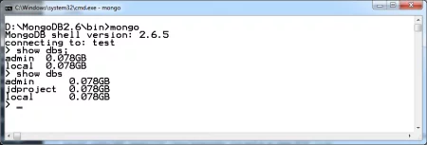](https://www.journaldev.com/wp-content/uploads/2015/07/mongodb-use-jdproject-db.png)

Connect to newly created “jdproject” MongoDB database, see newly created “jduser” MongoDB Collection & “jduser” Collection data as shown below

use jdproject;

show collections;

db.jduser.find();

[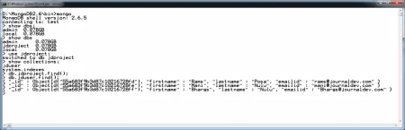](https://www.journaldev.com/wp-content/uploads/2015/07/mongodb-jduser-collection-data.png)

That’s about Integration of Node JS Platform with MongoDB module and perform basic operation.

If you are not familiar with “How to install MongoDB software, how to configure it, how to start MongoDB server, how to connect to MongoDB Connection and Mongdb Commands”, please go through MongoDB Tutorial available in JournalDEV website.

We will discuss “How to perform CRUD operations on MongoDB Database” in my coming posts.

# Introduction to Bower

There are many tools and libraries available today that makes our development task easier. In this post, we are going to introduce a great tool for managing the dependencies called **bower**.

## NodeJS and NPM

You have to [download and install NodeJS and NPM](https://nodejs.org/en/) before proceeding to the next sections. You don’t need to master NodeJS features to complete this tutorials but it’s always good to have a basic understanding on this technology. If you want to learn more about the environment set up and installation of NodeJS, you can go through the following posts otherwise you can jump to [next section](https://www.journaldev.com/8077/introduction-to-bower#bower).

* [Introduction to Node JS – Node.js Basics](https://www.journaldev.com/7397/introduction-to-node-js-basics)
* [Node JS Environment Setup – Node.js installation](https://www.journaldev.com/7402/node-js-environment-setup-node-js-installation)
* [Node.js Components – Node.js modules, NPM install update uninstall example](https://www.journaldev.com/7423/node-js-components-modules-npm-install-update-uninstall-example)

### Creating package.json File

package.json is a plain JSON text file which contains all metadata information about an application. You should create a package.json file to install an external tool as a development dependency. [Check this link](https://www.journaldev.com/7553/importance-of-package-json-in-node-js-applications) to get more information about package.json.

## Package Manager – Bower

You can use Bower as the package manager for the web applications. Bower will help you to find, fetch download the required packages for your application. Bower uses a manifest file called bower.json to keep track of these installed packages.

**Bower requires NodeJS, npm and Git. So make sure to install these components before installing bower.**

### Installing Bower Globally

We can globally install bower using the following command in the command line terminal.  
npm install -g bower  
Here **-g** makes the package manager run in the global mode.

### Installing Bower for a Project

If you want to restrict the installation to a project then remove the -g from the above command.  
npm install bower  
You can use the terminal available in JetBrains WebStorm.

* + Launch terminal.
  + Switch to the project root folder.( **My project folder : d:\Learn\Angular**)
  + Type the above command to install bower for a specific project.
  + You will see the something like the following image in your terminal.

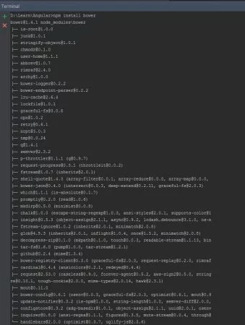

### Searching and Installing Packages Using Bower

You can find Bower packages using the online [component directory](https://bower.io/search/), or using the command line utility. You can use the following bower search command to find packages for your project.  
bower search <query>  
For example you can search angular packages using the following command and this will return a number of results.  
bower search angular  
We can install packages using bower install command. Bower installs packages to bower\_components. The following command is used to install packages.  
bower install <package>  
A package can be a GitHub shorthand, a Git endpoint or a URL. You can check out the [official bower site](https://bower.io/docs/api/#install) to get more details.

Let’s install angularJS for our project. You need the following command to install angularJS.  
bower install angular  
[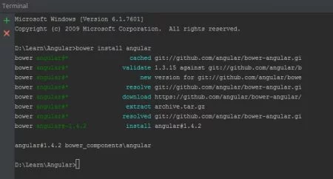](https://www.journaldev.com/wp-content/uploads/2015/07/angularBower.jpg)

You will see the installed angularJS under ***bower\_components*** folder.

[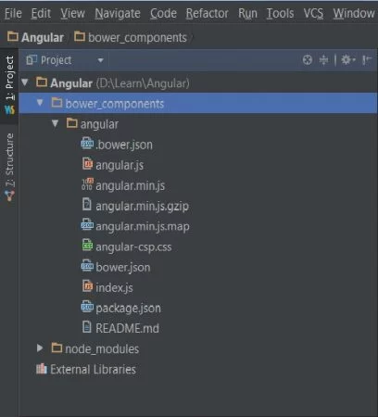](https://www.journaldev.com/wp-content/uploads/2015/07/bowerComponents.jpg)

## Using bower.json Configuration File

The bower.json file is a manifest file used to define packages that is similar to Node’s package.json file. If you are using multiple packages within your project, it’s a good practice to list these packages in a bower.json file. This will allow you to install and update packages with a single command – **bower install**.

You can create a bower.json file interactively using**bower init** command. The following image shows how to create a bower.json file.

[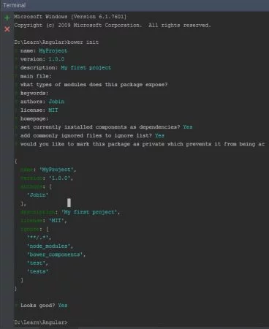](https://www.journaldev.com/wp-content/uploads/2015/07/bowerinit.jpg)

## bower.json Specification

|  |  |
| --- | --- |
| **Property** | **Description** |
| name | Unique name of the package. |
| version | Package’s semantic version number |
| description | A brief description of your package. |
| main | The entry-point files necessary to use your package |
| dependencies | Dependencies are specified with a key value pairs.Key must be a valid name.Value must be a valid version, a Git URL, or a URL. |
| devDependencies | Same as dependencies which is only needed for development ( ex : testing framework.) |
| ignore | A list of files for Bower to ignore when installing your package. |
| authors | Lists authors of the project. |
| repository | The repository in which the source code can be found |

## Managing Dependencies

Now we can look at maintaining dependencies in bower.json file. We will show you how to update the bower.json files.  
Let’s create a bower.json file using bower init command. You can see angular package in the **dependencies**array.

bower.json

{

"name": "My Project",

"version": "1.0.0",

"authors": [

"Jobin"

],

"description": "My first bower project.",

"license": "MIT",

"ignore": [

"\*\*/.\*",

"node\_modules",

"bower\_components",

"test",

"tests"

],

"dependencies": {

"angular": "~1.4.3"

}

}

We can add package to our project’s bower.json **dependencies**array – using  bower install --save command.  
The following command will add jquery package and update the above bower.json file.  
bower install jquery --save

You can see the **jquery**package as a ***dependency*** in the updated json file.

bower.json

{

"name": "My Project",

"version": "1.0.0",

"authors": [

"Jobin"

],

"description": "My first bower project.",

"license": "MIT",

"ignore": [

"\*\*/.\*",

"node\_modules",

"bower\_components",

"test",

"tests"

],

"dependencies": {

"angular": "~1.4.3",

"jquery": "~2.1.4"

}

}

You can also add any package to the devDependencies array using bower install --save-dev command.  
The following command will add the testing framework **jasmine** as a devDependency

bower install jasmine --save-dev

You can see the following updated json file with added devDependency.

bower.json

{

"name": "My Project",

"version": "1.0.0",

"authors": [

"Jobin"

],

"description": "My first bower project.",

"license": "MIT",

"ignore": [

"\*\*/.\*",

"node\_modules",

"bower\_components",

"test",

"tests"

],

"dependencies": {

"angular": "~1.4.3",

"jquery": "~2.1.4"

},

"devDependencies": {

"jasmine": "~2.3.4"

}

}

## Listing, Updating and Uninstalling Packages

* You can use the list command to find the installed packages in your project.

bower list

* You can use update command for updating the packages specified in your bower.json file.  
  Use bower update for updating all the packages.

bower update

* You can use the following command if you want to update the selected packages.

bower update <package>

* Uninstalling is also a straightforward action using the uninstall command.

bower uninstall <package>

* You can also uninstall multiple packages in the following way.

bower uninstall <package1>  <package2>  
**Bower** is a wonderful tool that can be used to solve the fundamental issues like finding, fetching and downloading the required packages for your application.

That’s all about bower and you will see more angularJS tutorials in the coming posts.

# JSON Server (json-server)

Today we will look into a very handy tool json-server, which can give you a mock rest json server in a minute.

In a regular enterprise application, you work with many teams and third party APIs. Imagine you have to call a third party [restful web service](https://www.journaldev.com/9170/restful-web-services-tutorial-java) that will get you JSON data to work on. You are in a tight schedule, so you can’t wait for them to finish their work and then start your own. If you wish to have a mockup Rest Web service in place to get the demo data for you, then [json-server](https://github.com/typicode/json-server" \t "_blank) is the tool you are looking for.

## JSON Server

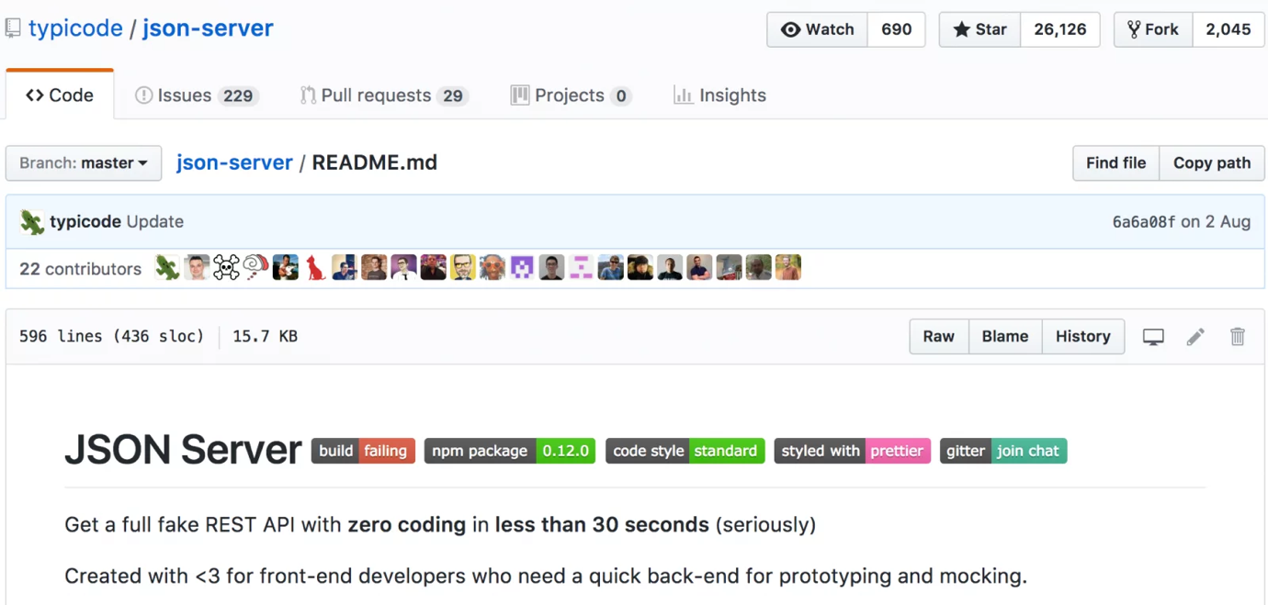

JSON Server is a Node Module that you can use to create demo rest json webservice in less than a minute. All you need is a JSON file for sample data.

### Installing JSON Server

You should have NPM installed on your machine. If not, then refer this post to [install NPM](https://www.journaldev.com/7423/node-js-components-modules-npm-install-update-uninstall-example).

Below shows the one liner command to install json-server with output on my machine.

$ npm install -g json-server

npm WARN deprecated graceful-fs@3.0.8: graceful-fs v3.0.0 and before will fail on node releases >= v7.0. Please update to graceful-fs@^4.0.0 as soon as possible. Use 'npm ls graceful-fs' to find it in the tree.

/usr/local/bin/json-server -> /usr/local/lib/node\_modules/json-server/bin/index.js

- bytes@2.3.0 node\_modules/json-server/node\_modules/raw-body/node\_modules/bytes

/usr/local/lib

└─┬ json-server@0.8.10

├─┬ body-parser@1.15.1

│ └── bytes@2.3.0

├─┬ compression@1.6.1

│ └── bytes@2.2.0

├─┬ lowdb@0.10.3

│ └─┬ steno@0.4.4

│ └── graceful-fs@4.1.4

├─┬ update-notifier@0.5.0

│ └─┬ configstore@1.4.0

│ ├── graceful-fs@4.1.4

│ └─┬ write-file-atomic@1.1.4

│ └── graceful-fs@4.1.4

└─┬ yargs@4.7.0

├─┬ pkg-conf@1.1.2

│ └─┬ load-json-file@1.1.0

│ └── graceful-fs@4.1.4

└─┬ read-pkg-up@1.0.1

└─┬ read-pkg@1.1.0

└─┬ path-type@1.1.0

└── graceful-fs@4.1.4

$

### Checking json-server version and options

$ json-server -v

0.8.10

$ json-server -help

/usr/local/bin/json-server [options] <source>

Options:

--config, -c Path to config file [default: "json-server.json"]

--port, -p Set port [default: 3000]

--host, -H Set host [default: "0.0.0.0"]

--watch, -w Watch file(s) [boolean]

--routes, -r Path to routes file

--static, -s Set static files directory

--read-only, --ro Allow only GET requests [boolean]

--no-cors, --nc Disable Cross-Origin Resource Sharing [boolean]

--no-gzip, --ng Disable GZIP Content-Encoding [boolean]

--snapshots, -S Set snapshots directory [default: "."]

--delay, -d Add delay to responses (ms)

--id, -i Set database id property (e.g. \_id) [default: "id"]

--quiet, -q Suppress log messages from output [boolean]

$

### Run JSON Server

Now it’s time to start our json-server. Below is a sample file with my employees json data.

{

"employees": [

{

"id": 1,

"name": "Pankaj",

"salary": "10000"

},

{

"name": "David",

"salary": "5000",

"id": 2

}

]

}

Important point here is the name of array i.e employees. JSON server will create the REST APIs based on this. Let’s start our json-server with above file.

$ json-server --watch db.json

\{^\_^}/ hi!

Loading db.json

Done

Resources

https://localhost:3000/employees

Home

https://localhost:3000

Type s + enter at any time to create a snapshot of the database

Watching...

Don’t close this terminal, otherwise it will kill the json-server. Below are the sample CRUD requests and responses.

### JSON Server GET – Read All Employees

$ curl -X GET -H "Content-Type: application/json" "https://localhost:3000/employees"

[

{

"id": 1,

"name": "Pankaj",

"salary": "10000"

},

{

"name": "David",

"salary": "5000",

"id": 2

}

]

$

### Get Employee based on ID from json-server

$ curl -X GET -H "Content-Type: application/json" "https://localhost:3000/employees/1"

{

"id": 1,

"name": "Pankaj",

"salary": "10000"

}

$

### JSON Server POST – Create an Employee

$ curl -X POST -H "Content-Type: application/json" -d '{"name": "Lisa","salary": "2000"}' "https://localhost:3000/employees"

{

"name": "Lisa",

"salary": 2000,

"id": 3

}

$

### JSON Server PUT – Update Employee Data

$ curl -XPUT -H "Content-Type: application/json" -d '{"name": "Lisa", "salary": "8000"}' "https://localhost:3000/employees/3"

{

"name": "Lisa",

"salary": 8000,

"id": 3

}

$

### JSON Server DELETE – Delete an Employee

$ curl -X DELETE -H "Content-Type: application/json" "https://localhost:3000/employees/2"

{}

$ curl -GET -H "Content-Type: application/json" "https://localhost:3000/employees"

[

{

"id": 1,

"name": "Pankaj",

"salary": "10000"

},

{

"name": "Lisa",

"salary": 8000,

"id": 3

}

]

$

As you can see that with a simple JSON, json-server creates demo APIs for us to use. Note that all the PUT, POST, DELETE requests are getting saved into db.json file.

Now the URIs for GET and DELETE are same, similarly it’s same for POST and PUT requests. Well, we can create our custom URIs too with a simple mapping file.

### json-server custom routes

Create a file with custom routes for our json-server to use.

routes.json

{

"/employees/list": "/employees",

"/employees/get/:id": "/employees/:id",

"/employees/create": "/employees",

"/employees/update/:id": "/employees/:id",

"/employees/delete/:id": "/employees/:id"

}

We can also change the json-server port and simulate like a third party API, just change the base URL when the real service is ready and you will be good to go.

Now start the JSON server again as shown below.

$ json-server --port 7000 --routes routes.json --watch db.json

(node:60899) fs: re-evaluating native module sources is not supported. If you are using the graceful-fs module, please update it to a more recent version.

\{^\_^}/ hi!

Loading db.json

Loading routes.json

Done

Resources

https://localhost:7000/employees

Other routes

/employees/list -> /employees

/employees/get/:id -> /employees/:id

/employees/create -> /employees

/employees/update/:id -> /employees/:id

/employees/delete/:id -> /employees/:id

Home

https://localhost:7000

Type s + enter at any time to create a snapshot of the database

Watching...

It’s showing the custom routes defined by us.

### json-server example with custom routes

Below is the example of some of the commands and their output with custom routes.

$ curl -X GET -H "Content-Type: application/json" "https://localhost:7000/employees/list"

[

{

"id": 1,

"name": "Pankaj",

"salary": "10000"

},

{

"name": "Lisa",

"salary": 8000,

"id": 3

}

]

$ curl -X GET -H "Content-Type: application/json" "https://localhost:7000/employees/get/1"

{

"id": 1,

"name": "Pankaj",

"salary": "10000"

}

$ curl -X POST -H "Content-Type: application/json" -d '{"name": "Lisa","salary": "2000"}' "https://localhost:7000/employees/create"

{

"name": "Lisa",

"salary": 2000,

"id": 4

}

$ curl -XPUT -H "Content-Type: application/json" -d '{"name": "Lisa", "salary": "8000"}' "https://localhost:7000/emloyees/update/4"

{

"name": "Lisa",

"salary": 8000,

"id": 4

}

$ curl -XDELETE -H "Content-Type: application/json" "https://localhost:7000/employees/delete/4"

{}

$ curl -GET -H "Content-Type: application/json" "https://localhost:7000/employees/list"

[

{

"id": 1,

"name": "Pankaj",

"salary": "10000"

},

{

"name": "Lisa",

"salary": 8000,

"id": 3

}

]

$

JSON server provides some other useful options such as sorting, searching and pagination. That’s all for json-server, it’s my go to tool whenever I need to create demo Rest JSON APIs.

# How to Build a Node.js Application on Docker

Docker has been the latest trending topic over the past couple of years and if you haven’t been to space or spent some time in the caves, you probably must have come across this tech buzzword.

**So, what is docker?**

Docker is a free and open source development platform that allows developers to develop and deploy their applications in containers. Containers come with their own libraries and frameworks and enable applications to be developed in an isolated environment from the host Operating System. This guide takes you the process of how to build a Node.js application on Docker.

## So why should you build your application on docker?

1. The consistency of the working environment. The application will run in the same manner for all developers and clients alike at whatever phase; be it in development, staging or in production.
2. Docker containers ship their own libraries and frameworks as earlier pointed out. Containerization eliminates the need for manually installing libraries and dependencies. You can launch a fully fledged and complete development environment ready for deployment of your application.

Now let’s dive in and see how you can build a Node.js application on Docker.

### Prerequisites

* Docker installed on your system
* [NPM](https://www.journaldev.com/7423/node-js-components-modules-npm-install-update-uninstall-example)

## Step 1: Creating the Node.js application

The first step is to create a Node.JS application  
Create a new directory and navigate into it

$ mkdir nodejs-app && cd nodejs-app

Next, initialize the directory with npm (NodeJS Package Manager). This creates a package.json file that will handle dependencies of the application.

$ npm init

**Sample Output**

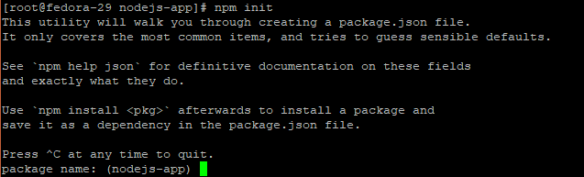

You will be prompted for the details of the application such as Name, Version, description, etc. You can decide to specify your won preferred details of if you desire to leave the defaults as they are, simply press ENTER.

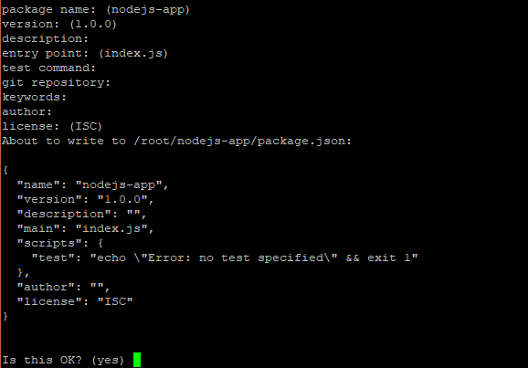

At the end of the prompt, type Yes to accept the changes.

Next, run

$ npm install express –save

**Sample Output**

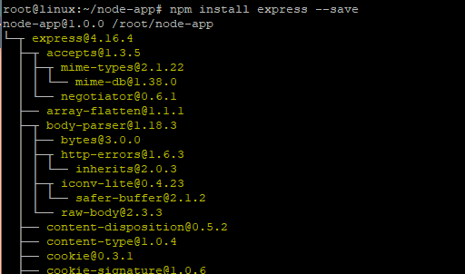

This adds the express framework as the first dependency

## Step 2. Creating files for the Node.js application

We are going to create 3 files for the Node.Js application.

* index.js
* index.html
* about.html

For the index.js file, add the following content.

const express = require('express')

const app = express()

app.get('/', ( req, res ) => {

res.sendFile(`${\_\_dirname}/index.html`)

})

app.get('/about', (req, res) => {

res.sendFile(`${\_\_dirname}/about.html`)

})

app.listen(3000, () => {

console.log('Listening on port 3000!')

})

The above file creates 2 routes for the index.html and about.html pages which listen on port 3000.

For the index.html file, add some test content as shown.

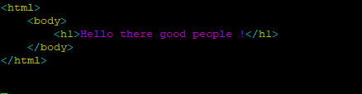

For the about.html page, add the following content.

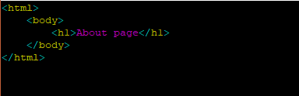

Great! Our Node.JS application is now ready for launching.

## Step 3: Running the Node.JS application

To run the application, run the command

$ node index.js

**Sample Output**

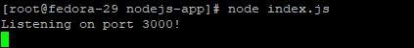

Now, open your browser and go to index.html page by typing the URL as shown

https://ip-address:3000

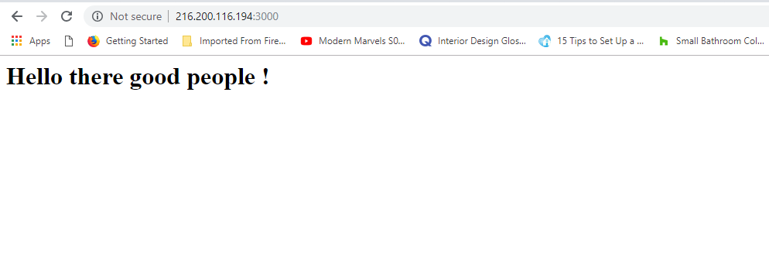

To visit the about.html page, append the /about at the end of the URL

https://ip-address:3000/about

## Step 4: Dockerizing the Node.JS application

Next, you are going to define a working environment inside your container. This working environment encompasses dependencies, pre-installed applications, and libraries to mention just a few. The container doesn’t come with the whole Operating System, as opposed to a VM. It only ships dependencies, applications and config files and this makes it much lighter, faster, and resource friendly than ordinary virtual machines.

Contrary to VM, however, the container doesn’t hold the whole operating system—just applications, dependencies, and configuration. This makes Docker containers much lighter and faster than regular VM’s.  
Create a file dockerfile in the app’s directory

$ touch dockerfile

Add the following content

FROM node:carbon

WORKDIR /usr/src/app

COPY package\*.json ./

RUN npm install

COPY . .

EXPOSE 3000

CMD ["node", "index.js"]

The first line indicates that we went to use the latest node version for building our image  
The second line creates the directory /usr/src/app for holding the app’s code inside the image.  
The third and fourth line copies the package.json, file and runs the npm install command

The **COPY** instruction bundles our app inside the Docker image, so our HTML files and index.js file in our case.  
The **EXPOSE** instruction exposes the 3000 port that our app uses.  
Finally, the **CMD** instruction specifies the command that needs to be run for our app to start.

## Step 5. Building the Node.JS application

With the dockerfile now created, let’s build our app using the command. Please note the presence of space and period sign at the end.

$ docker build -t node-app .

**Sample Output**  
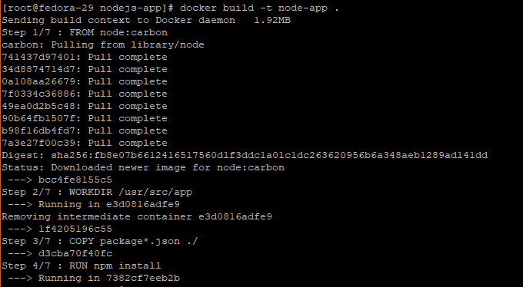

The -t enables you to tag your docker image. In this example, we have tagged our docker image as node-app

To verify the existence of the application run

$ docker images

**Sample Output**

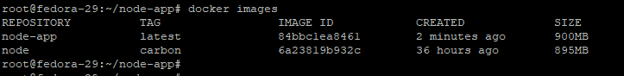

## Step 6. Run docker container

We can now launch our container

# docker run -p 8080:3000 -d node-app

This redirects the app to open via port 8080 instead of port 3000.

**Sample Output**

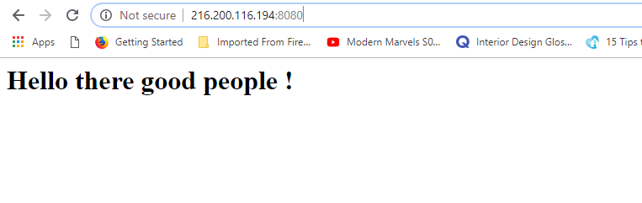

## Step 7. Pushing the App to Docker hub

The final step will be to share the node application to docker hub where people can access it and download its image.  
To do so, ensure you have an account at https://hub.docker.com  
Next, build the image again using your docker hub credentials as shown

# docker build -t [USERNAME]/tag .

In our case, the command will be

# docker build -t winnieondara/node-app .

Where username => winnieondara  
Image tag => node-app

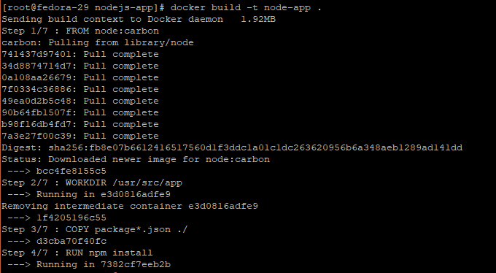

Next, login to docker on the terminal using your credentials

# docker login

**Sample Output**

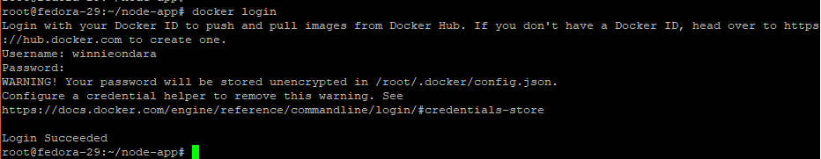

Finally, push the image to docker hub

# docker push winnieondara/node-app

**Sample Output**

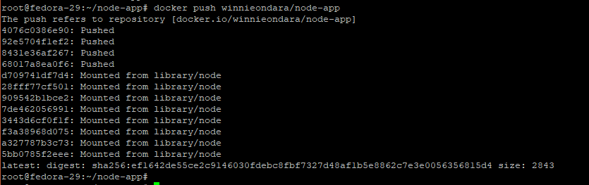

Congratulations! Now, log in to your docker account and be sure to find your Node.JS application image as shown. The image can then be downloaded and run by other users

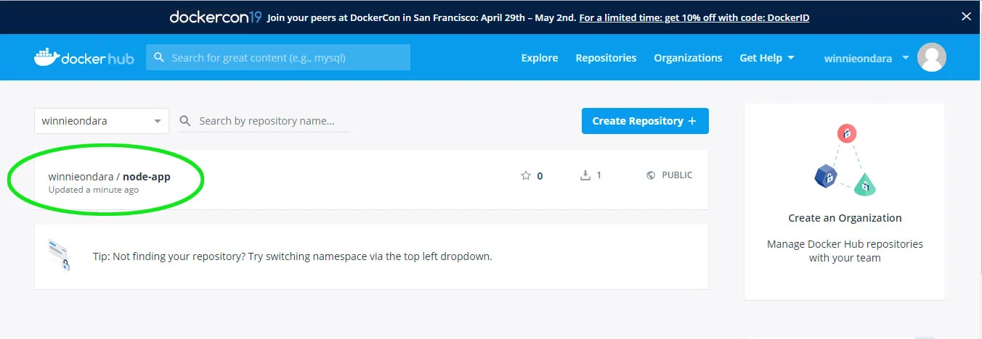

This wraps up our tutorial on how to build a Node.js application on docker. Feel free to give it a try and tell us how it went. We value your feedback.